* Water splits apart ionic compounds
* if, in a solution, an ionic compound will dissolve but may not precipitate
* precipitation is when a compound solidifies at the bottom of a solution
* solution - solute + solvent
* All ionic compounds will dissolve in water
* Concentration is not uniform in a mixture
* Electrochem uses a lot of solubility rules
* Need redox reactions (not learned in )
* All solutions can be mixtures but all mixtures cannot be solutions
  + Solutions are homogeneous
  + Mixtures are heterogeneous
    - Where the concentration is not uniform
* PBCL is sol in hot water
* If there's no precipitate then there is no reaction
* Alkali will not dissolve
* O2 is a molecule because there are more than 1 atom
* IONIC COMPOUNDS DO NOT CREATE MOLECULES
  + Create a FORMULA UNIT
    - Uses formula mass
    - Because there must be many atoms for the crystal lattic structure to form & the push and pull to keep stable
  + Form a crystal lattice form
    - 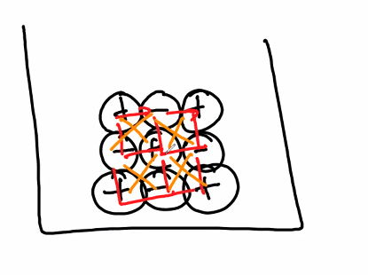
* A double replacement reaction will always have ionic compounds
  + Mut be aqueous because the individual elements will not be pulled apart without being submerged in water
* Soluble there will be no solid form
* soluble means they will not create a precipitate
  + Soup of ions
* Insoluble means they will create a precipitate
* Cl-,Br-, I- are soluble except for Ag1+, Hg22+, Pb2+ F- are soluble except for IIA metals
  + Means that these will only bond with the latter elements
* Not in the list of soluble means insoluble
* NITRATES ARE ALWAYS SOLUABLES
* Solubility trumps insolubility
  + Insol + sol will not priptate
* Molarity - measuring concentration
  + **M = mol/1L of solution**
    - M aka moler
  + Mol = M * mov
  + Higher molarity less solvent
    - Always water in
    - 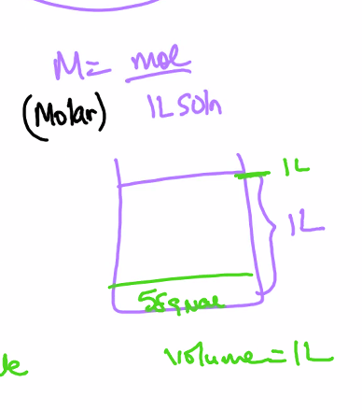
* MOlality - another form of concentration
  + ***m =* Mol of solute/1kg of solvent**
  + Just the weight of the solvent (water) has to equal 1 kg
  + Used extensively in pharmaceuticals
  + DEL NORTE TESTS BUT AP DOESN’T
  + 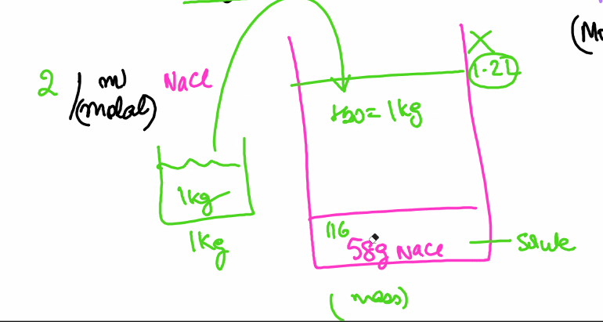
* Most AP stoich will be gram to gram
  + Converting grams of one element to grams of another element

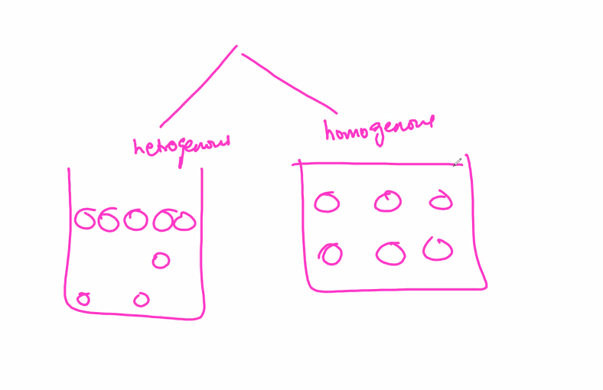

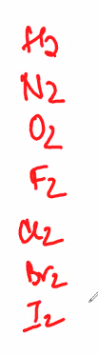

* These are diatonic
  + Unstable on their own, incomplete outermost shell that makes electrons repel each other

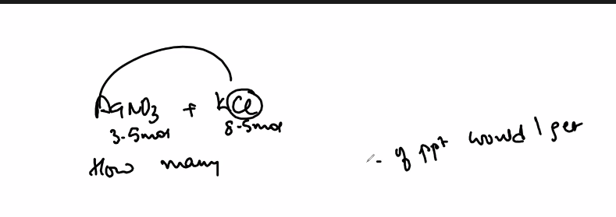

* Example solubility stoich question
* Equilibrium
* A <> B
  + Increase in B shifts equilibrium to the left * **favors the reactants**

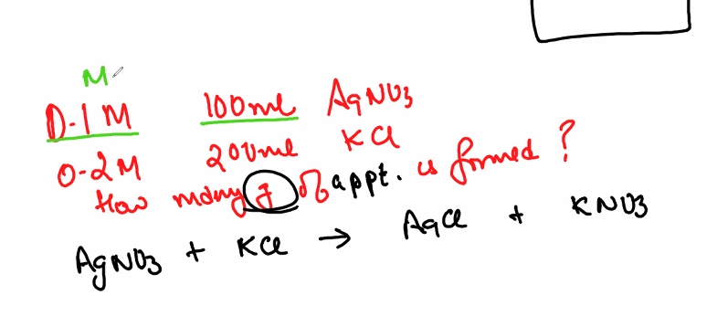

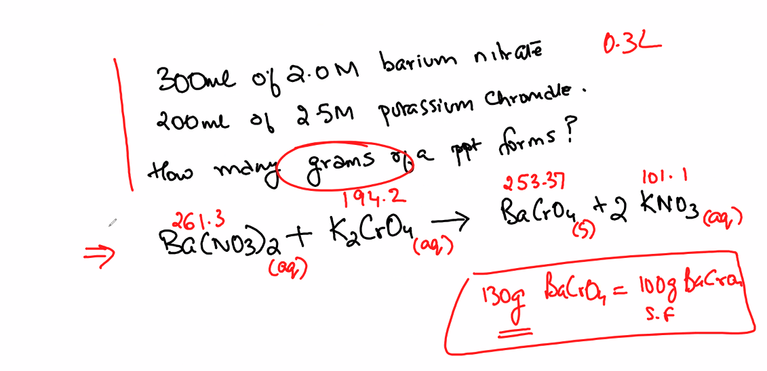

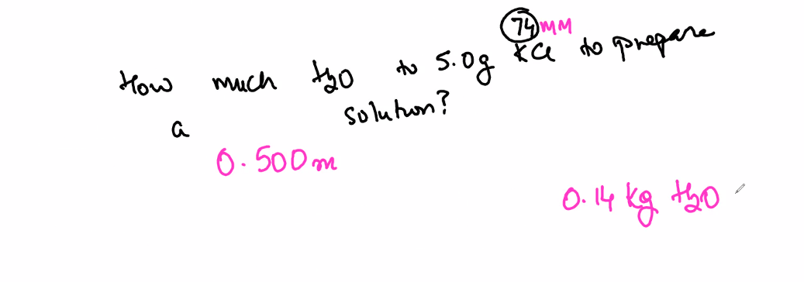

**DAY 2**

* 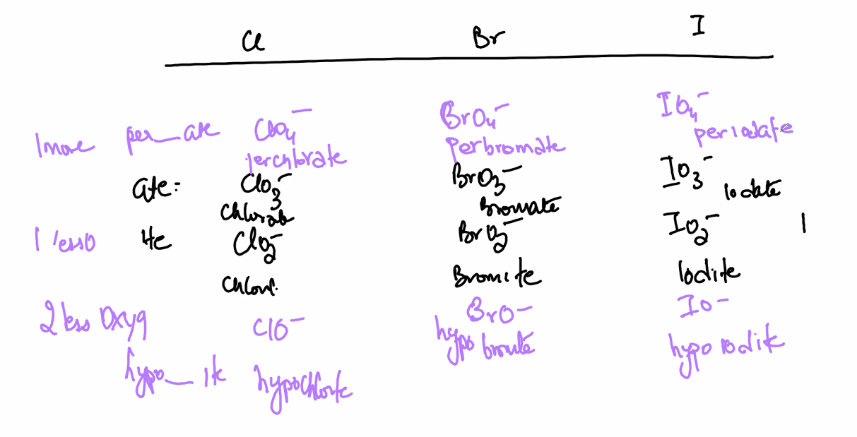
  + Ate - highest num of oxygen
  + Its - highest num of oxygen-1
  + Hypo - highest num of oxyget -2
  + Per highest num of oxygen +2
* Empirical formula from percent concentration (Always want to assume that the concentration is out of 100g, so 95% concentration = 95g)
  + 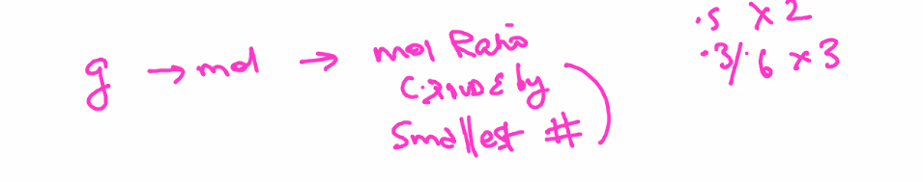
  + Only applicable for covalent compounds since there can be multiple combinations in which electrons are shared
* Combustionr reactions are exothermic reactions that react with o2
  + Synthesis reactions can be combustion reactions
  + hydro carbon reacts with oxygen
* Stoich problems checklist
  + Read the problem, identify any formulas, masses, percents, reactants and products
    - CREATE A MOLECULAR EQUATION, USE EQUATION TYPOE LAWS (double displacement n stuff)
* Double displacement reaction have net ionic equations
  + (builds on solubility rules)
  + 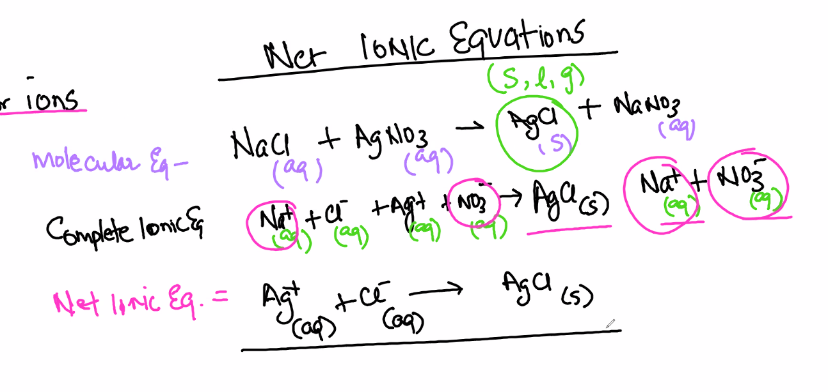
    - Molecular eq where compounds are grouped
    - Complete ionic eq where ALL ions are splits and NONAQUEOUS compounds are grouped
      * Spectator ions are ions that do not take part in a reaction, the ions that stay aqueous on both sides of hte equation
    - Net ionic eq do not contain spectator ions on the reactants or products
* 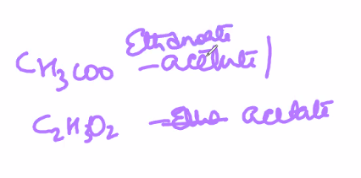
  + CH3OO (Ethanoid Used in organic chem) & C2H3O2 are both acetates
* Transition metal charges can be found by finding the charge of the anion in the compound
  + Some transition metals have constant charges
* 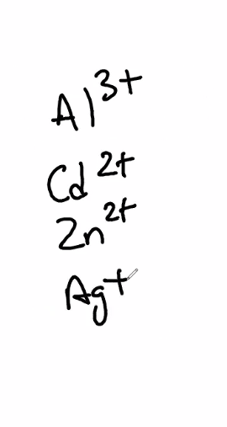
* Boron has -6 charge
* Berryllium needs 2.4
* Only aqueous solutions can be acids and bases
* Anything with hydroxide (OH, HO) are bases
* Acids are covalent compounds
  + When submerged in water, hydrogen can become positively charged and create an acid
  + H+ in a molecular compound is an Acid
* Water (H2O) can be both acids and bases
  + Amphoteric is the term used to describe this
* Percent yield is real/theoretical
  + 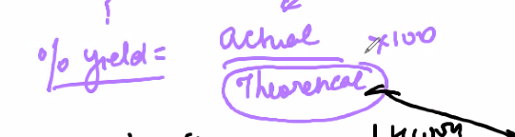
* Limiting reactant quicker
  + Divide the mols of reactant by the coeff and the smallest result is the limiting reactant
  + 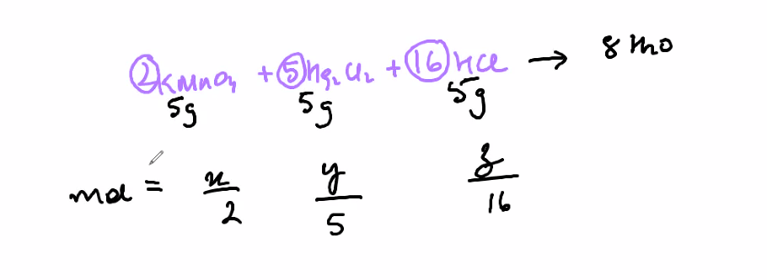
  + 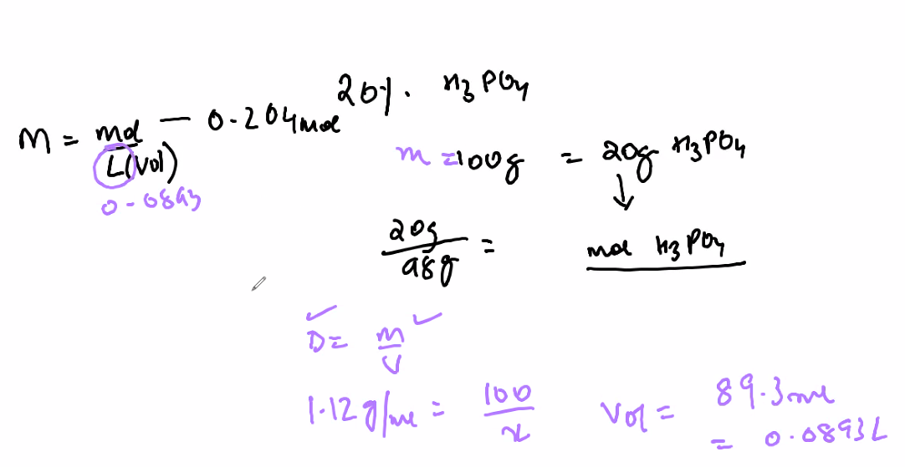
  + Redox reactions
    - Look at the movement of electrons
      * Studied in electrochem
    - Charge must be preservedf on both sides of an equation
    - OIL
      * Oxidation
        + Anything that loses elections is oxidizes
    - REDUCTION
      * Reduced
        + Anything that gains electrons is reduced
    - Oxidation numbers/states (assigned per atom)
      * Used to find what is oxidizing or reduced
      * 1. Look at freelements
        + Any free elements are given oxidation number of 0

O2 has oxidation num of 0 because there is nothing attached to the element

* + - * 2. Look at the monoatomic ions
        + The hcarge of the ion is the oxidation number

Na+ has oxidation num of +1

O2- has oxidation num of -2

* + - * 3. Polyatomic ion/compound = ox#s have to add up to the charge
        + Ox num of each element must add up to the charge
        + NO3
      * 4. Compounds:
        + alkali metals: +1 ox #
        + Alkaline earth metals: +2 ox #
        + F: -1 ox #

The above three are constant

* + - * + H: +1 ox #
        + H (With a metal): -1 ox #
        + O: -2 ox #
        + Halogens: -1

these will vary to elements above them

Eg a halogen will vary to an oxygen

* + - H2O
      * H is not w/ a metal so its harge is +1
        + There are 2 H atoms

Charge is +2

* + - * Oxygen is -2 charge
      * Net charge is +2 + (-2) -> 0
    - If ixizidation number increases, it becomes oxidized
      * Li -> li+ + e-
        + Li has charge o 0 since it is a free element
        + Li+ gains an electron

Oxidizes

* + - Subcript is hte number of atoms
      * Hg2^+2
        + Ox num of 1 since the net charge of this is 2 and oxidation num is per element
  + BALANCE an equation (combining)
    - ½ rxns
      * One ½ at a time
        + Balance all elements except H & O
        + Balance all O by adding h20
        + Balance all H by adding h+
        + Balance charge by adding e-
      * Repeat for 2nd ½ rxn
      * Add both ½ rxns
        + ELECTRONS MUST CANCEL OUT (multiply by a coefficient toriase)
        + Charges should be the same on both sides
      * Cancel when the same element is on both sides of the equation
        + This means that the element doesn’t react so it is un
  + When the same element undergoes reduction and oxidation, the reaction is a disproportionation reaction
    - 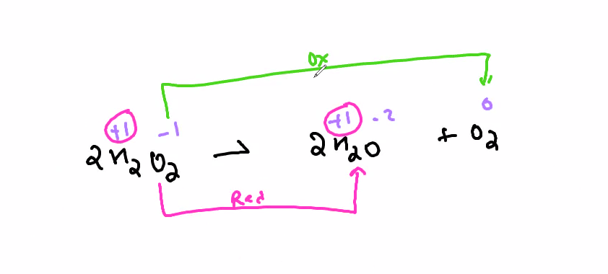
      * Since ox num hydrogen stays the same, oxygen is being reduced in 2h2O and oxidated in O2 > mens that only 2H2O takes part in reduction and oxidation
    - 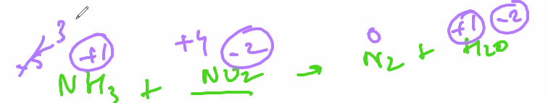
      * In this instance, because the ox nums of H and O stay the same, it does not take part in reduction and oxidation and is ignored when writing the half equations
* DILUTION EQUATIONS
  + When given molarity and volume, convert to moles & solve
    - M2V2 = M2V2
    - 20 * x = 1.5 * 2
* Isotopes have a different number of neutrons than the naturally occurring element
  + (different mass)
* 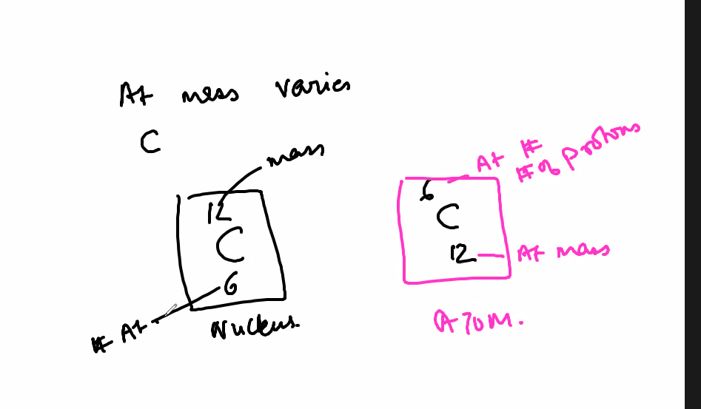
  + The right side references the whole atom
    - At # on top, mass on bottom
  + The left side references just the nucleus
    - Mass on top, at # on bottom
* Radioactivity
  + How unstable a nucleus (not an element)
    - Protons have positive charge
    - Neutrons have no charge
      * Neutrons are needed to balance the repulsion of the positive charges of protons
        + Acts as a buffer between the proton & proton repulsion in the nucleus
      * After 20 protons more neutrons than the protons are needed to counterbalance their force
      * Any element past 82 protons are called unstable
* Emission
  + product
* Production
  + Product
* Decay
  + product
* Bombardment
  + reactant
* Adding
  + Reactant
* Electron capture
  + Reactant
  + 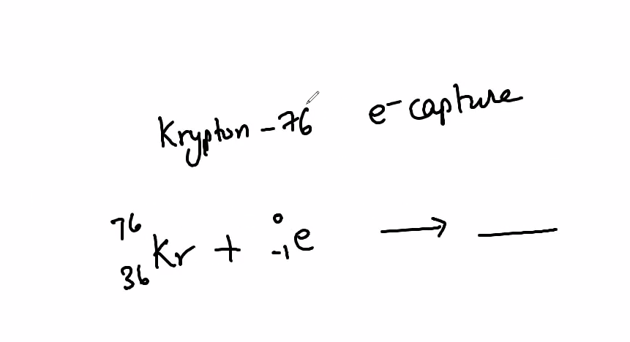\
    - Krypton-76 undergoes electron capture
      * Kr & electron is on reactant
      * If another element is not listed, then assume only one element is produced
* 5 particles that interact with the nucleus
  + protron
    - 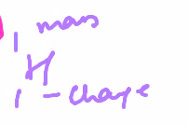
    - Like hydrogen with the charge at the bottom
  + Alpha
    - 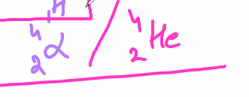
  + Beta
    - 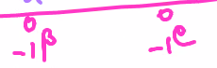
    - Negative charge
  + Gamma
    - 
    - No mass no charge
  + Positron
    - 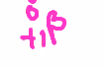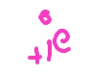
  + Electron
    - Beta particle
    - 
  + Neutron
    - 
    - No charge
* Balancing nuclear reaction
  + Universal rules
    - Net atomic number of prods & reacftants have to match
    - Net charge of prods & reactants have to match
  + 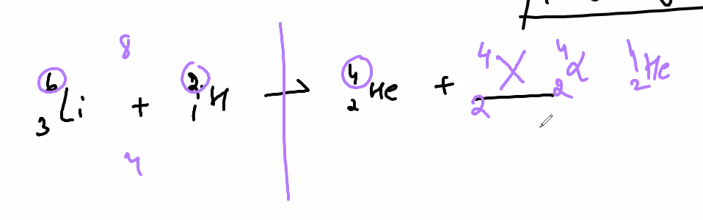
    - Net mass of reactants and net mass of prods must be equal
      * U can subtract the mass of 4-2-He from the net mass of the reactants to find the remainder
  + 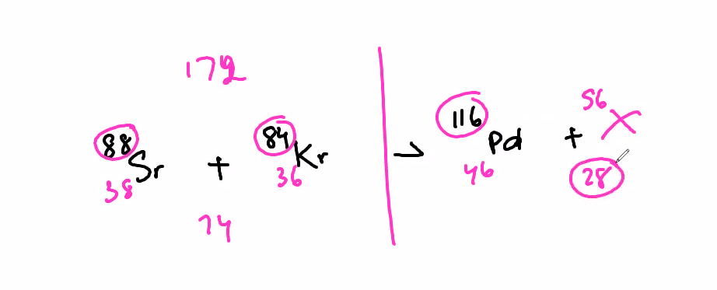
* Example of AP Chem nuclear chem equation
  + 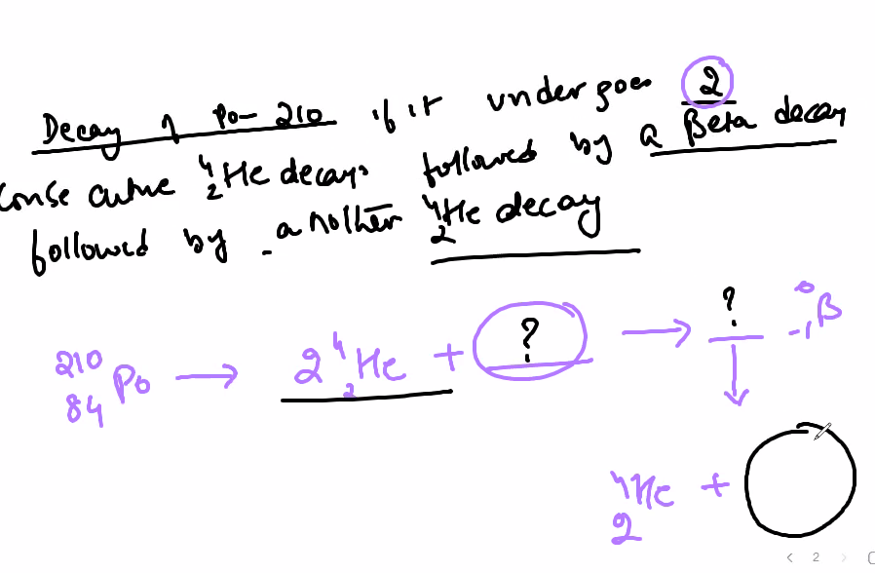
  + Multiple steps
    - decay 2 consecutive alpha decays
    - Followed by a beta decay
    - Followed by another alpha decay
      * These steps are shown by arrows that take the result of one decay to result of another decay
* Half-life is the tiem it take for an element to decay half of its original mass
  + 100g - 50g takes 30 days, 25 to 17.5g = 30 days
* All radio active rxns are always 1st order
  + 1st order means that the speed of hte equation depends on the concentration of the reactants
    - This means that hte half life will stay constant with varying masses
      * 1 concentration / 1 speed = .5 concentration / .5 speed
  + Isotopic decay means that the reaction is radioactive
* Organic chemistry
  + Organic involves organisms
    - Carbon cannot create 4 bonds with itself
      * 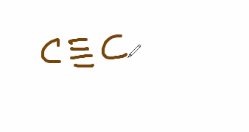
      * Tetrahedron structure of a carbon has only 3 bonds & 1 bond facing the other way
    - Hydrocarbons are the base of all organisms
      * Pure hydrocarbons have only hydrogen and carbon
      * Alyphatic
        + Compounds can be…

Straight

Where the structure is straight like a line

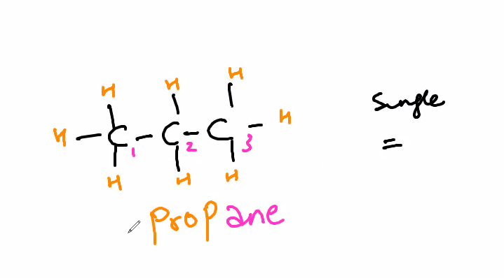

Ring

Branched

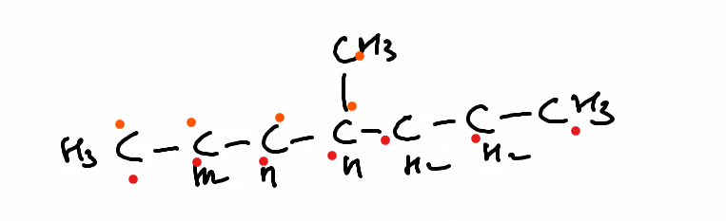

The base is the # of carbon atoms within the largest chain

The example is a 7 carbon atom base

* + - * + Naming alyphatic

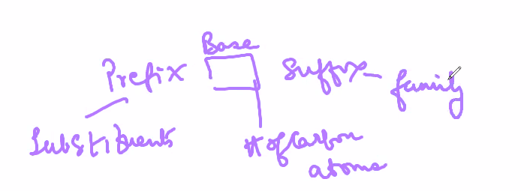

Prefix - substituents (aka functional groups)

Prefixes for the num of the same substituant

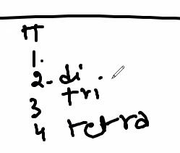

Used when more than one hydrogens are replaced by the same substituent

There can be more than one substiuent

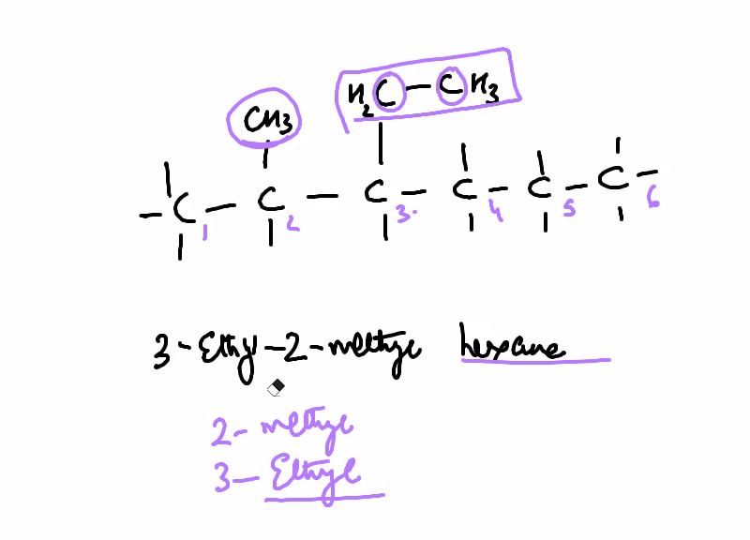

When something replaces hydrogen

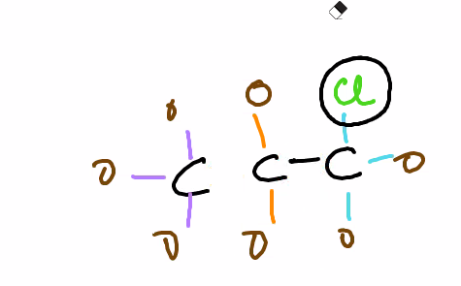

Must give place of substituents

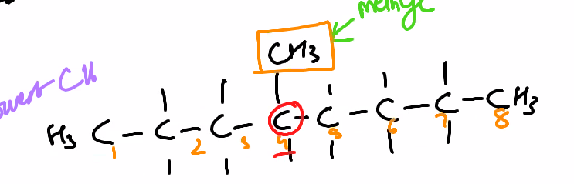

In the example, you would name it 4-methyl octane (4 is the number of the carbon in which it bonds with)

Must choose the lowest position

If there is another hydrocarbon, the suffix is the hydrocarbon

ONLY IF THE HYDROCARBON IS NOT PART OF A CHAIN



Eg: methyl octane

Naming a hydrocarbon substituent

Only worry about its base/ num of carbon atoms

-yl is the suffix always

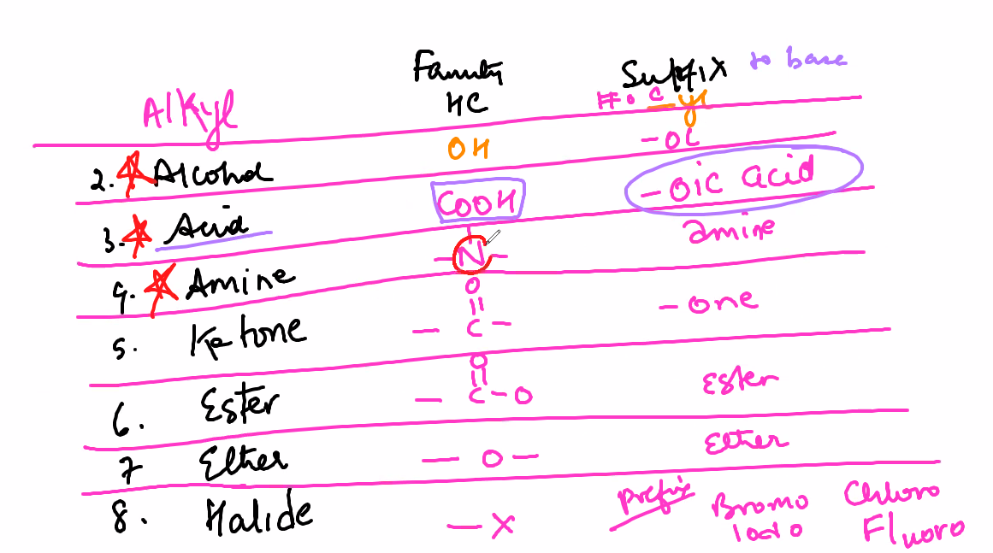

Amines are weak bases

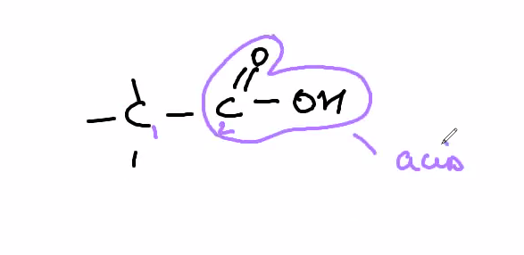

Creates COOH

Called ethanoic acid

(an means it is alkide)

-oic is the suffix of the acoid

If functional groups are on opposite sides/the same side they are named differently

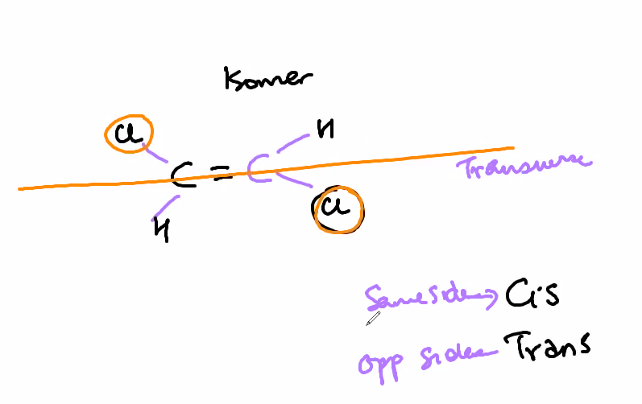

Base - # of carbon atoms

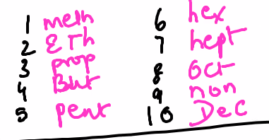

4 is “but” but is pronounced beaut like in beauty

Suffix - family

-ane (single bond alkanes)

-ene (at least one double bond alkines)

-yne (at least one triple bond alkene)



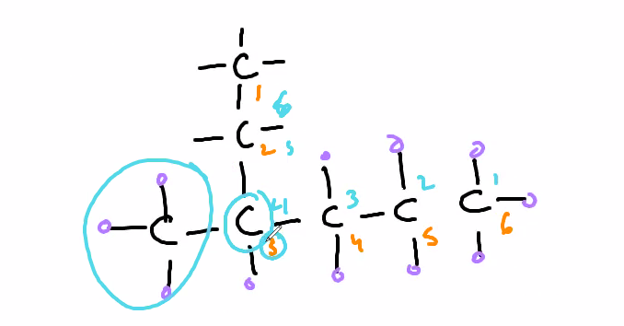

In this instance the substiuent is the leftmost hc cuz the longest chain goes from the top to the right

Because counting from top to right has the carbon bonded with the substituent

* + - * Aromatic
        + Benzene based
        + “These compounds can be found chiefly in crude oil and natural gases. The main difference between aliphatic and aromatic hydrocarbons is that aliphatic hydrocarbons have a high carbon-to-hydrogen ratio whereas aromatic hydrocarbons have a less carbon-to-hydrogen ratio.Oct 31, 2017”
    - Carbon has 4 valence electrons & is able to bond with itself and create an octet
      * Makes it desirable for creating life
      * 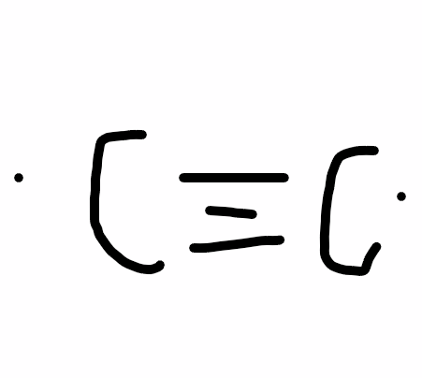
    - proteins , carbohydrates, lipids
      * Creates macromolecules
        + Large molecules
* The same compound can be written in diff ways
  + 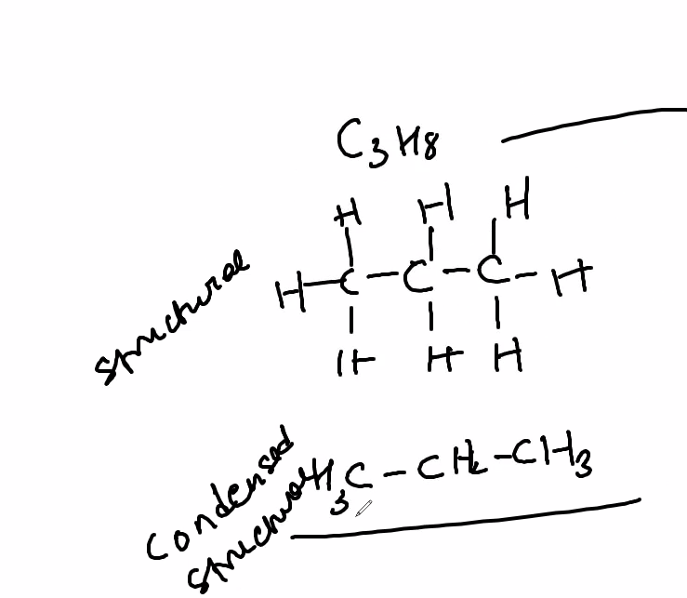
    - Structural
    - Condensed structural
      * Valence electrons are not shown\
* Acids
  + Acids are formed when the pull of hte water is stronger than the pull of the covalent bond and pulls apart the h+
  + Bases are formed when the pull of hte water pulls apart a hydroxide ion
  + A strong acid/base
    - All atoms of an element are pulled away from a compound
  + A weak acid/base
    - Some atoms are pulled apart
* pH
  + 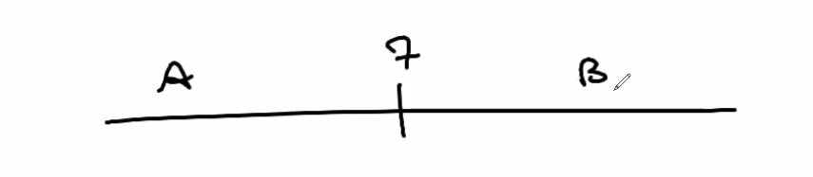
  + 7 is neutra
    - Less than 7 is acidic
    - Greater than 7 is basicl
  + 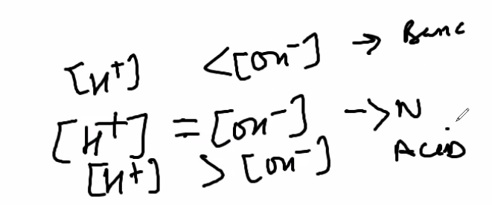
  + 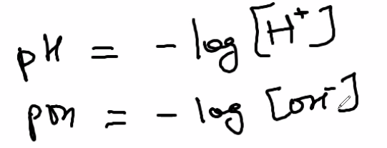
* NEED TO MEMORIZE
  + Strong acids/strong bases
    - 7 strong acids
      * 3 halo acids
        + HCL
        + HBR
        + HI
      * 2 chloro acids
        + HCLO4 - perchloric
        + HCLO3 - chloric
      * Misc
        + HNO3 NITRIC
        + h2SO4
    - 8 strong bases
      * Grpl 1,2
      * HOH - this is a water (very basic)
      * LiOH
      * NaOH
      * KOH -> Ca(OH)2
      * RbOH -> St(OH)2
      * CsOH -> Ba(OH)2
      * Fr OH - this is very readioactive
  + Solubility rules
  + Polyatomic ions
* Isomers
  + Compounds with the same formula but diff structure
  + Molecules can spin & atoms can spin on the axis of their bond
    - 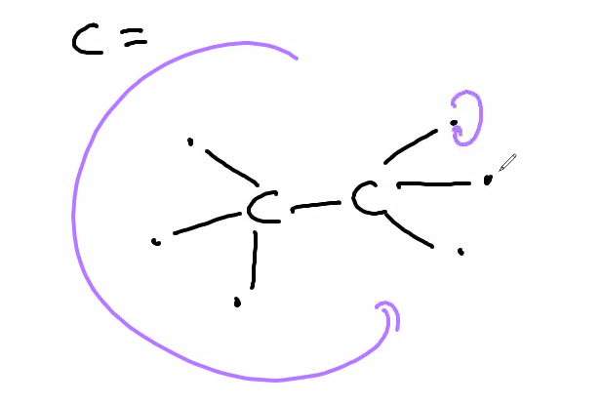
  + Stronger bonds (aka single bonds closer to the origin atom/compound or double bonds) make it less likely for them to spin
* Gasses
  + 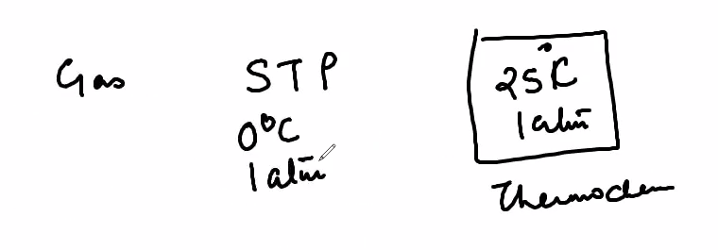
    - STP in labs/experiments is diff for gasses because different gasses cannot be standardized & compared
  + Always in kelvin
    - Other measurements of temperature can be negative
  + Gas laws
    - 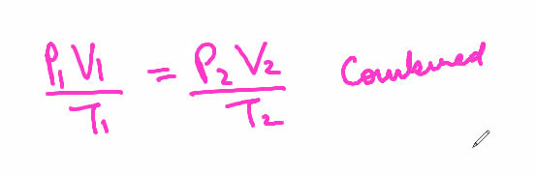
      * Pressure & volume are directly related
      * PV & T are inversely related
        + 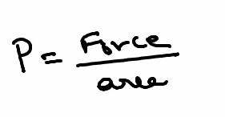
    - 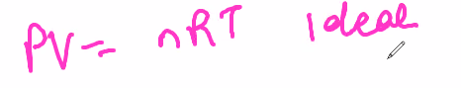
      * N = num of moles
      * R = L / mol * kelvin
        + 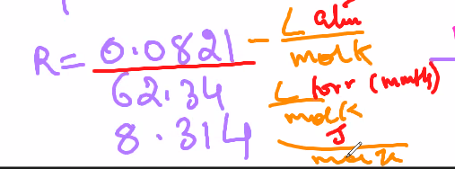
    - 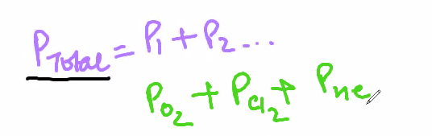
      * 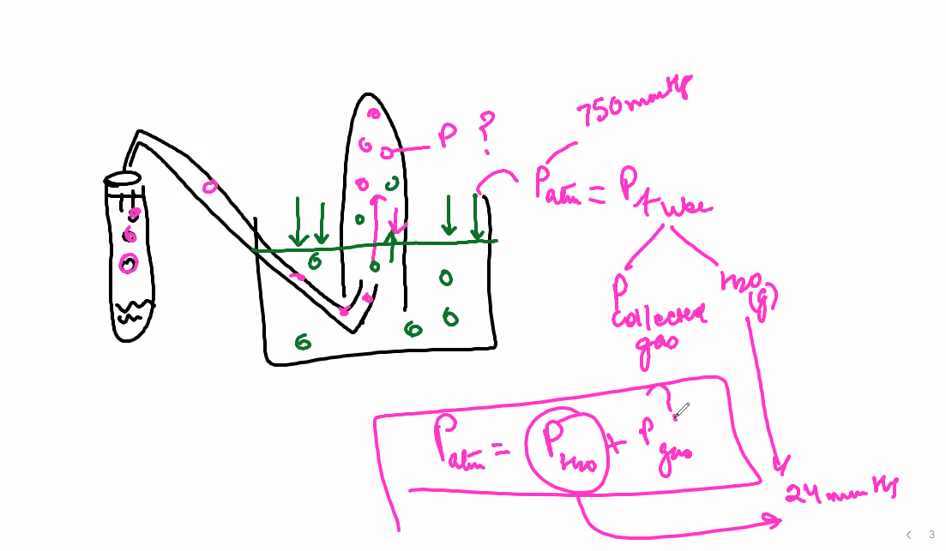
        + Patm is the same out of and inside teh container
        + Inside the tube, water vapor & the gas are emitted so your Ptotal equation must account for htat
      * Find moles of each gas, add up all moles, use PV=nRT to find pressure
      * Find individual pressures then add
    - Combined & ideal both implement changes
      * Ideal gas laws involve mass & moles
    - 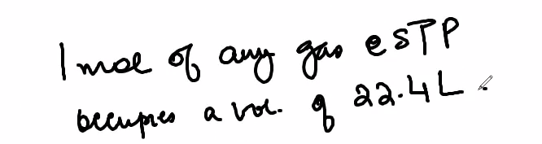
      * 22.4 L is occupied by any gas at STP
    - 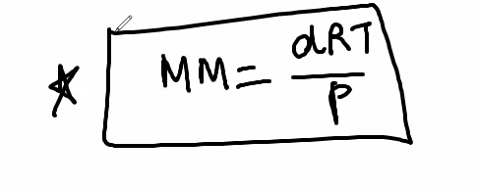
      * D = density
        + mass/volume
      * R = gas constant
      * T = temp
      * P = pressure
      * MM = molar mass
  + Kinetic Molecular Theory
    - States that all molecules are moving
      * As molecules hit the walls of its container pressure is created
    - Temperature is the measure of the total kinetic energy of the molecules
      * Greater temp = greater KE
    - Same temp = same KE
    - Same KE != same speed
      * Greater mass = slower speed
    - 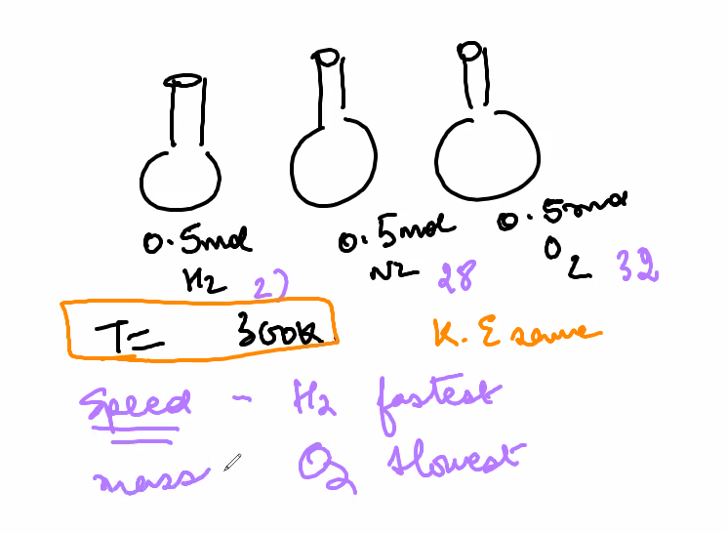
    - KE
      * 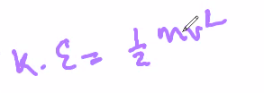
* Ideal gas
  + Gasses in the real world are imperfect because of the varying temp & pressure of all the other gasses in the atmosphere constantly
  + No real gasses are ideal
    - Ignore the basic force of attraction between gas particles (IMF)
  + Gasses taht have the least IMFs are most idela
    - Greater the molecule size, less ideal
    - Less pressure = more ideal
      * Decreases IMF since there is more space for particles to move
    - Greater temperature = more ideal
      * Greater KE = less IMF
    - Greater the volume, less ideal
      * Correlates to molar mass
  + 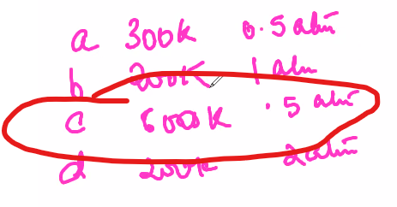
    - Example AP chem mc, which is most ideal
  + 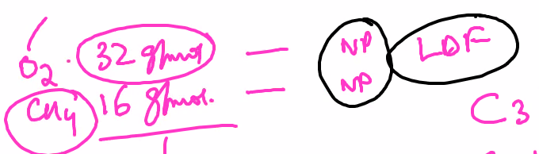
    - Example chem FRC, which is most ideal
      * Both are NP but CH4 is most NP
* Water displacement
  + 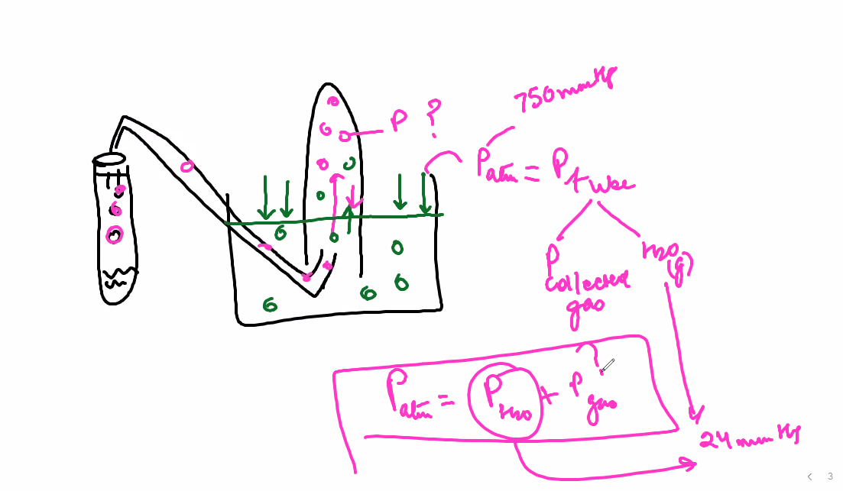
    - Account fro water vapor as a partialgas
  + Example AP test question
    - 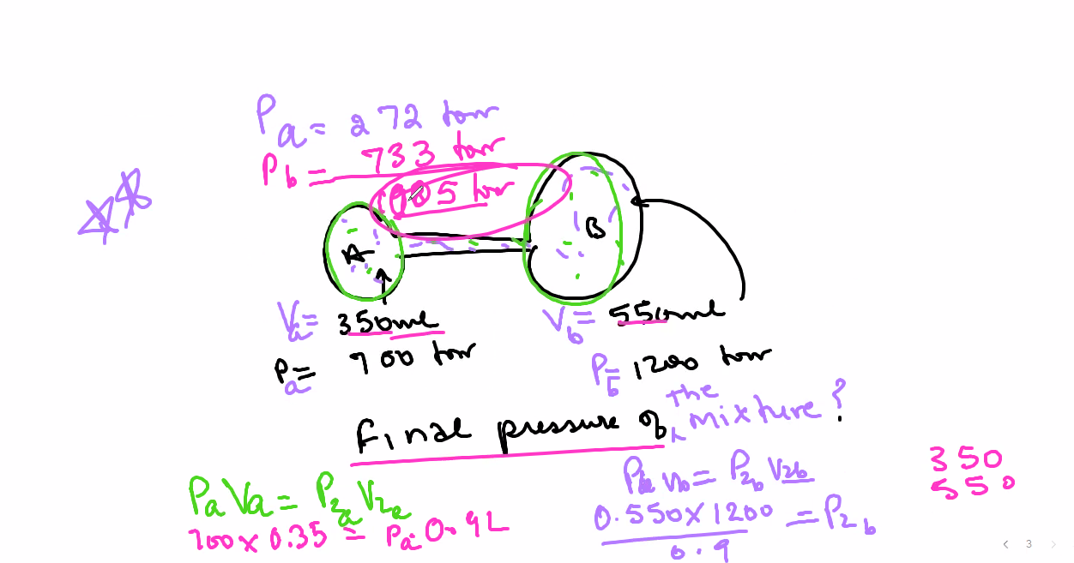
      * Use PV = PV for the initial vol and the total volume
* Diffusion & effusion
  + Diffusion means that gas particles move all the time
  + - This means that the gas with the greater molar mass will go slower
      * M2 = molar mass
      * HEaveir gas on top (m2 = greater molar mass)
  + Effusion is the ability of a gas to tescape through tiny hole
    - 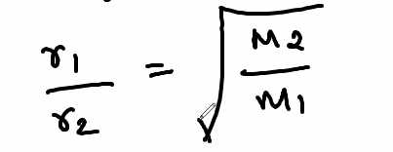
      * r = rate of escape
        + Rate = vol/time
* Decomposition is the type of reaction
* # of moles of gas is directly proportional to pressure
  + Always some water vapor
  + If a reactant is limiting, it does not release any pressure
  + 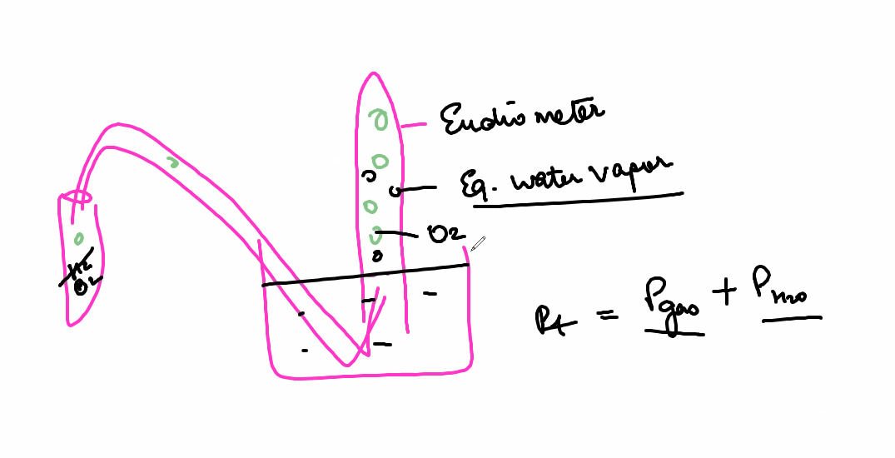
  + 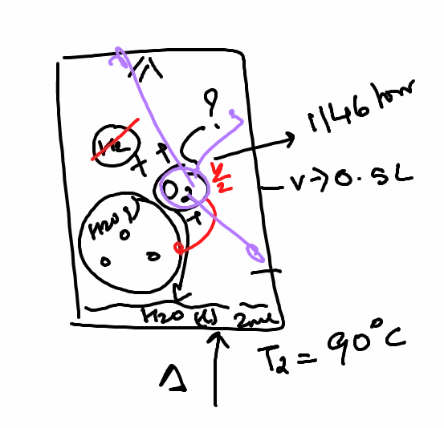
* Evacuated means there was no other gas before you put the reactants in
  + No evacuation means that the gas is contaminated
* Rigid means the volume does not change
* **IMF/POLARITY**
  + IMF = the forces between molecules
  + Ion vs polar
    - Ion -> p != e
    - Polar - > electrons indivudally have an insignificant amount of charge (very small), when the distribution of electrons around the molecule is uneven and multiple electrons are close to each other it becomes polar
      * Partial charge is created from an uneven distribution of electrons
        + Always negative
      * 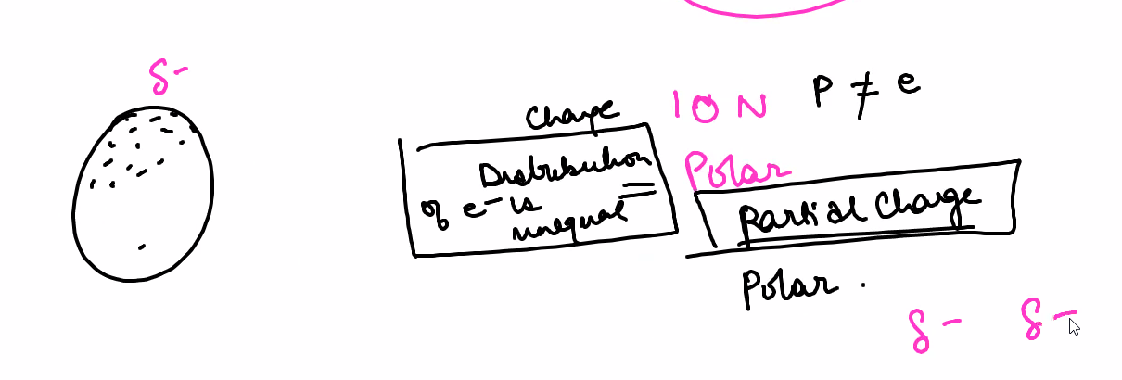
      * Overall charge is 0 since it is a molecule
    - Distribution can be temporary or permanent
    - Induced dipoles are createdf when a dipole (that has many electrons) attracts electrons from a nonpolar molecule
      * 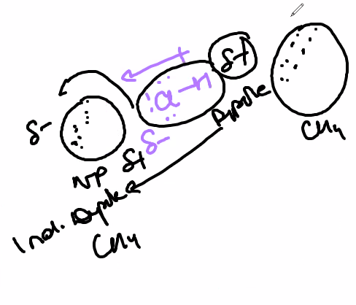
  + Polarity
    - 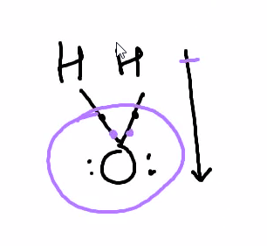
      * Lone pairs in a lewis structure mean that it is polar
      * Bcz ox is so electronegative, the electrons are so close tothe oxygen atom that the hydrogen technically has no electrons
    - Types of IMF
      * LDF
      * Dipole - induced dipole
      * Ion - induced dipole
      * Dipole-diple
        + The pos/neg dipoles attract to pos/neg dipoles of other molecules
      * Hydrogen bonding
        + Type of dp-dp
        + PURE HYDROCARBONS ARE NONPOLAR
        + Very strong
        + Only applies with multiple molecules
        + Sometimes the hydrogen can leave the molecule

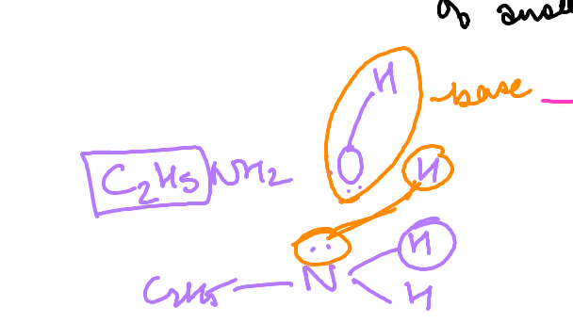

* + - * + Needs 2 electrons to bond
        + 2 conditions must be met

H in question has to be bonded to either F, O, or N

Bcz the electrons shared would be hogged by the extremely electronegative elements

H in question must be attracted to F, O, or N of another molecule

* + - * + Amines are weak bases because o hydrogen bonding
        + 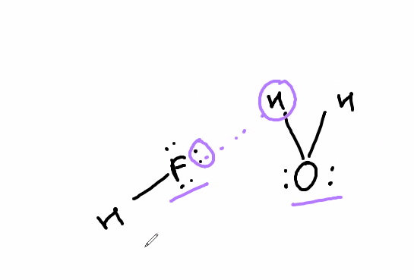
      * Ion - dipole
  + Nonpolar molecules
    - Only type of IMF possible is LDF
      * Lond dispersion forces
    - Create a temporary/induced dipole
* Fluorine, ox, and nitrogen is the 3 most electroneg elements
* Identifiy the most IMF
  + Dipole, if only given one compound, assume the molecule attracts other molecules
  + 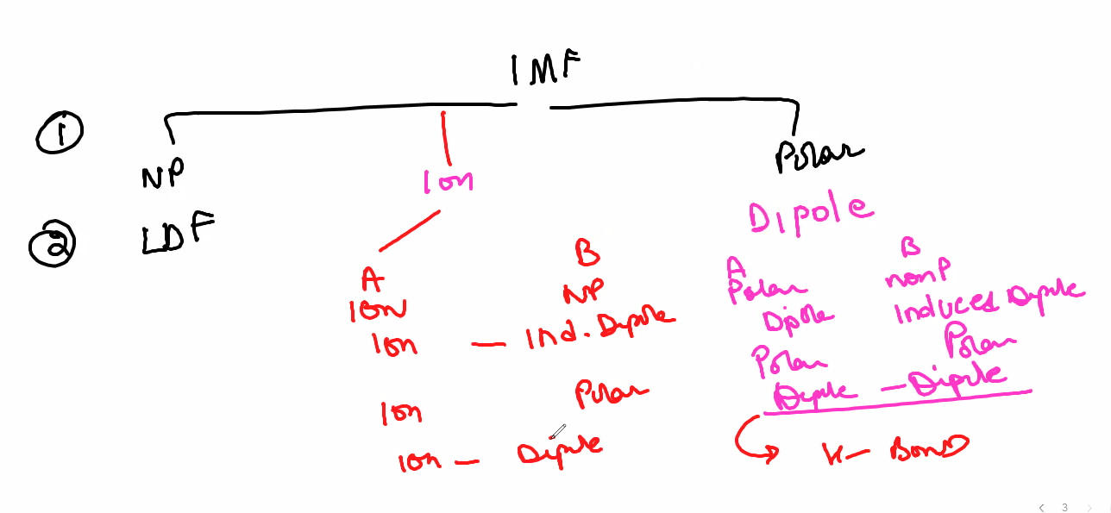
* Bigger the HC, the more insoluble it becomes
  + 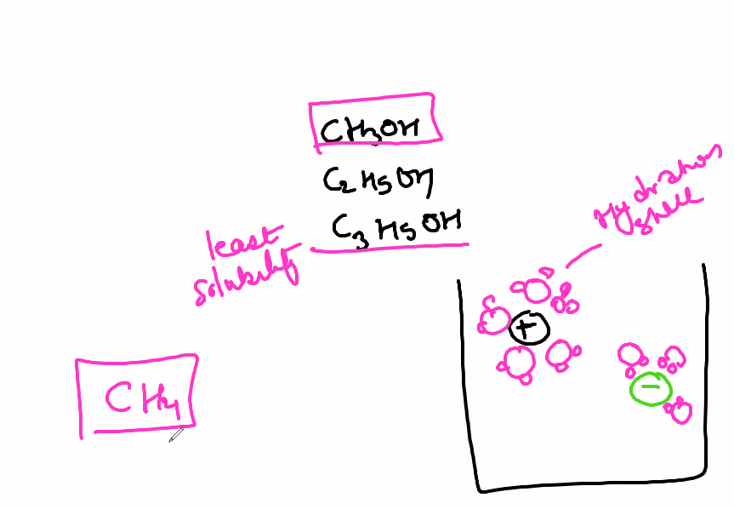
* How to tell if HCs are polar
  + 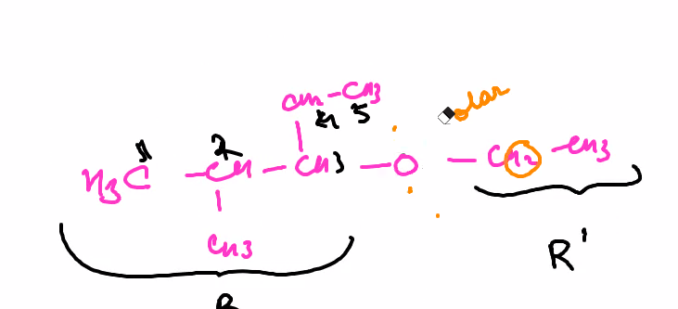
    - R refers to an alkine group
  + HC’s are normally polar
    - Only alcohols and acids can bond with other molecules
  + Look for valence electrons
    - Only if hydrogen bonds with FON, then it would be Hydrogen Bonding
* Mole fraction is # of moles of element / # of moles of total
* Molecular shape
  + 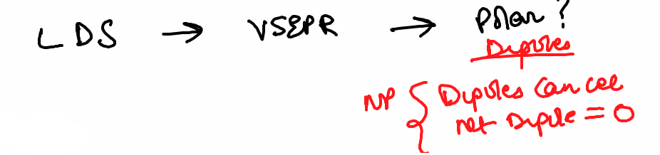
  + Will not be given an eng periodic table
  + Drawing lewis structure
    - Count total number of valence
    - Create a bond around an atom
    - Count the left over electrons
    - Compete octets of ur other atoms
      * 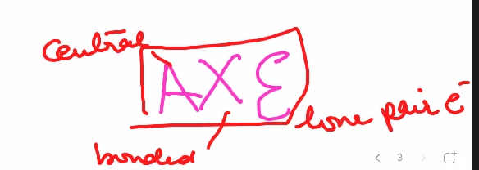
      * 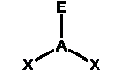
      * A is central
      * X is bonded atoms
      * E is lone pair of electrons on the central atom
    - Leftover electrons go to the central atoms
    - (once complete, if octects are incomplete, use double or triple bonds to complete)
  + Finding shape
    - Steric Number = A (# of Valence) + E
    - Match formula with table
      * 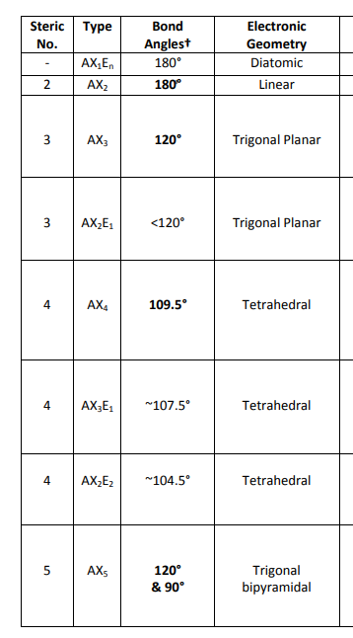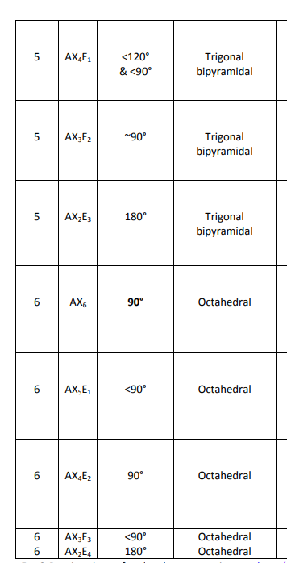
    - Vesper finds the angle at which the electrons would be farthest apart since electrons repel each other
    - Lone pairs of electrons always push greater than electrons on at atom
  + Dipoles created by electrons face away from the central atom
  + Dipoles created by atoms face towards teh central atom
  + 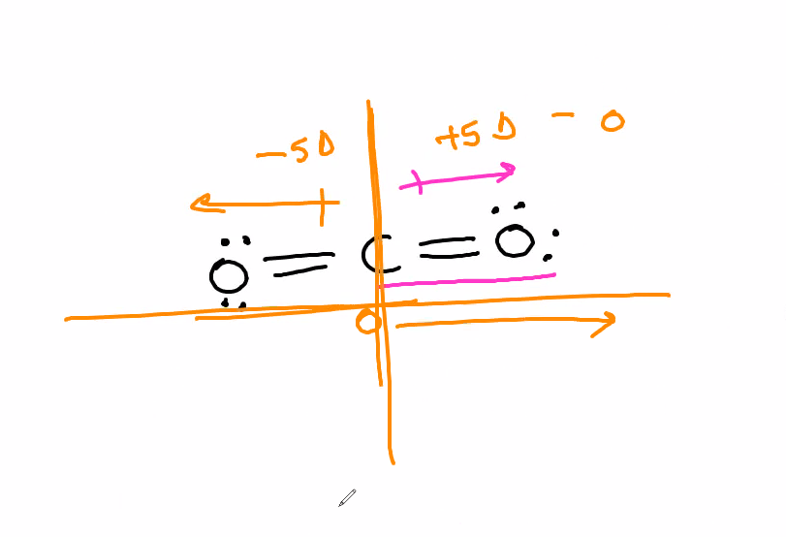
  + If the dipole arrows face opposite directions, the molecule is NP
    - Vice versa
* Le chatliers principles
  + Exothermic
    - Heat is in the products
      * Inc. temp -> left
      * Dec temp -> right
  + Endo thermic
* K: ration
  + Products:reactants
    - 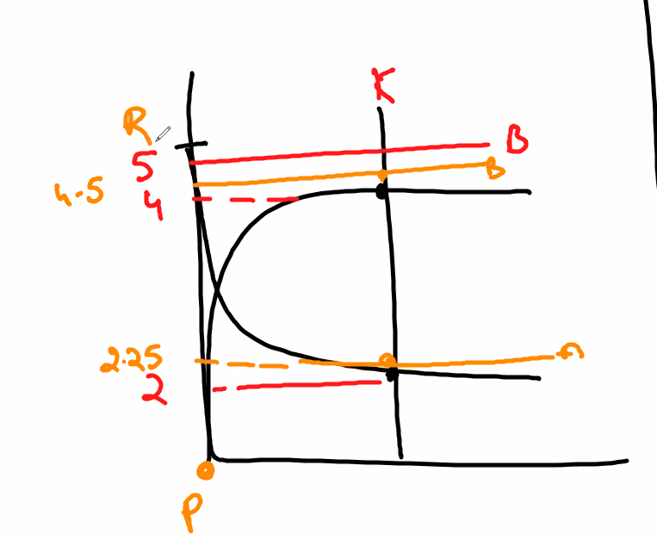
      * K is originally 4:2
      * Add 1 mole of B to increase the B concentration to 5
        + The 1 mole added to the product is used by the reactans so the reactants have to increase
    - No matter the shift, K stays the same
  + < 1: smaller reactants
  + >1: greater products
  + 1: equal products
  + Only temperature that can change the value of K
    - 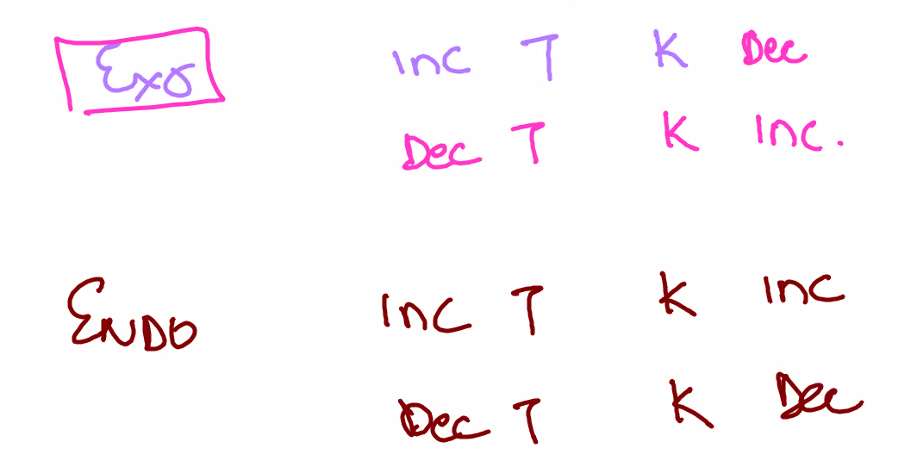
  + In questions, explain why products or reactants increase to change K
    - 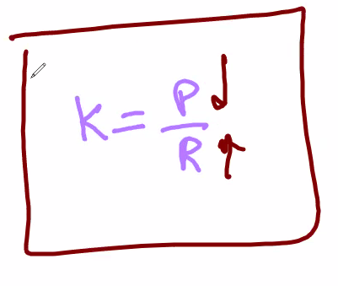’
  + 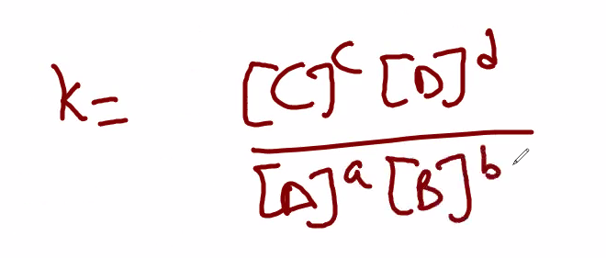
    - IGNORE SOLIDS & LIQUIDS BCZ THEY DO NOT EFFECT THE VALUE OF K
      * Premise of KSV
        + 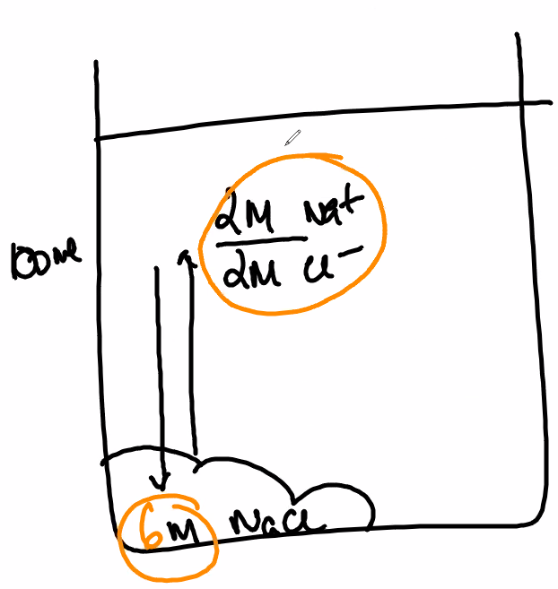
        + Since here, an amount has already been dissolved, adding more product or reactants of solids could not react & dissolve
  + Increase vol
    - Increases pressure
      * Shift to the place that which has less moles of gas
    - Adding an inert/noble gas increases pressure
* Reaction quotation
  + Subscripts are the unit of measurement when calculating K
    - 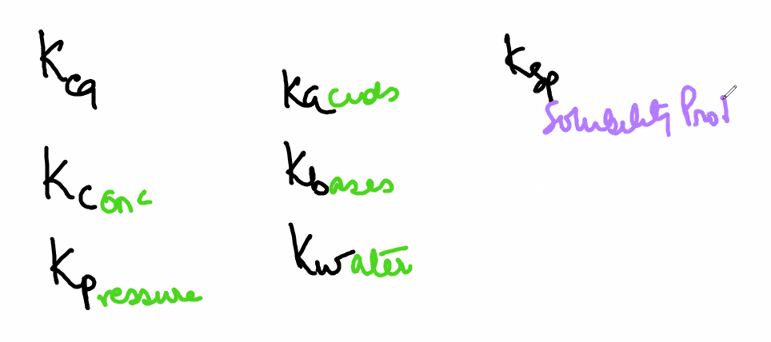
      * A, acids
      * B, bases,
      * W, water
    - Q -> reaction quotient
      * 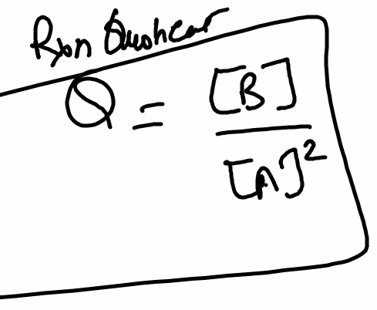
        + Follows the same rules as K

K is ONLY at equilibrium

Q is throughout the whole reaction

Used to see if the reaction has reach equilibrium

* + - * 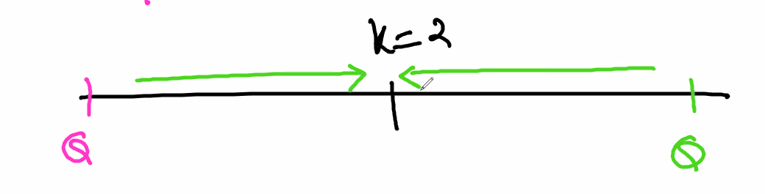
  + Heating & cooling curves
    - Tested in del norte but not AP
      * Applied to IMF in ap
* Heat
  + Energy is energy
    - Used for work
  + Heat is the transfer of thermal energy
  + Thermal energy is hte transfer of heat
  + Kinetic energy is the measure of temperature
* Enthalpy
  + q = energy (heat)
  + H = q + work
    - 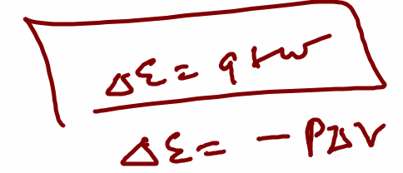
    - Work: contraction, expansion, exothermic, endothermic
      * Enthalpy should be negative since in order to be favorable/sustainable
        + Energy is being released & not taken in
* State function
  + Where you don’t find how you get somewher, ONLY CARE ABOUT THE CHANGE
    - △ = final - initial
      * For eq, find which side is final & initial based on the greater reaction
        + 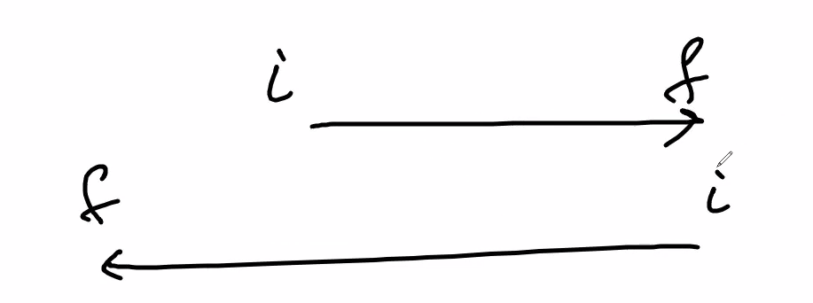
  + Enthalpy is a state function because you can’t measure how the reaction occurs
* System
  + Reaction taking place
  + Open system
    - Transfer of mnass & energy between syus & surroundings
  + Closed system
    - No transfer of mass
    - Transfer of energy
      * 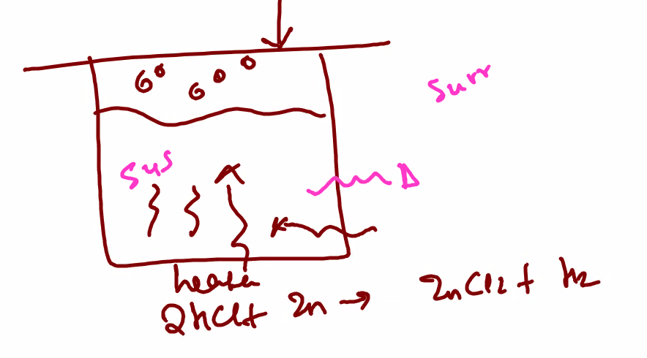
  + Isolated system
    - Where the system is within a vacuum
      * No mass or energy is transsfered
* Surroundings
  + Everything around the system
    - Surroundings if in open air
      * 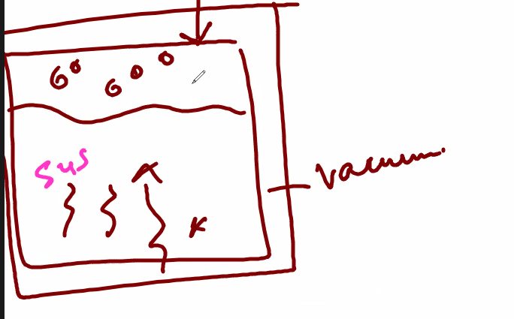
  + 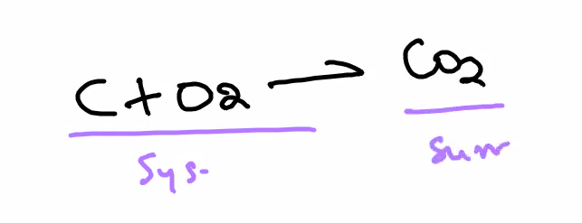
* Hess’s Law
  + 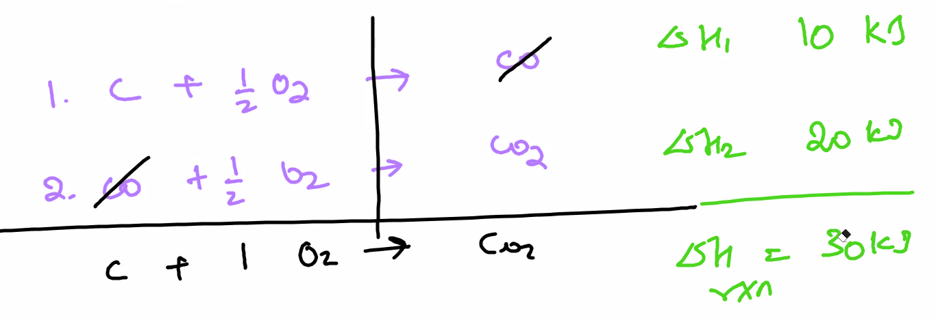
    - Hess’s law states that a reaction can have multiple steps
      * The steps can be manipulated to get the original reaction
        + 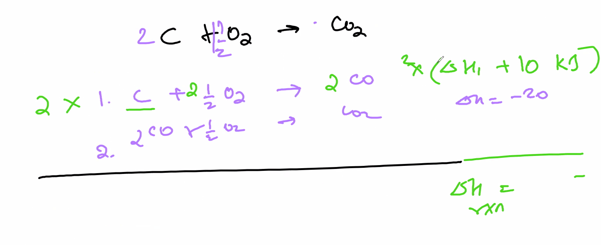

Enact the enthalpies done on the step by the changes made

Multiply by neg 1 to flip the reaction

Flip prods & reactants

* + - The sum of the enthalpies of hte reaction is the enthalpy of hte total reaction
* Entropy
  + 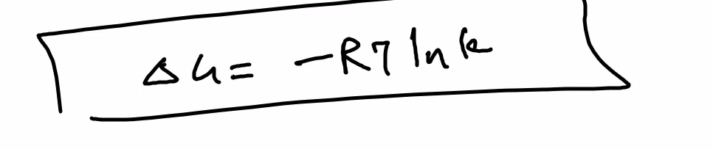
    - Energy from phase changes or disorder
      * Disorder is how the monitors are packed/arranged
        + 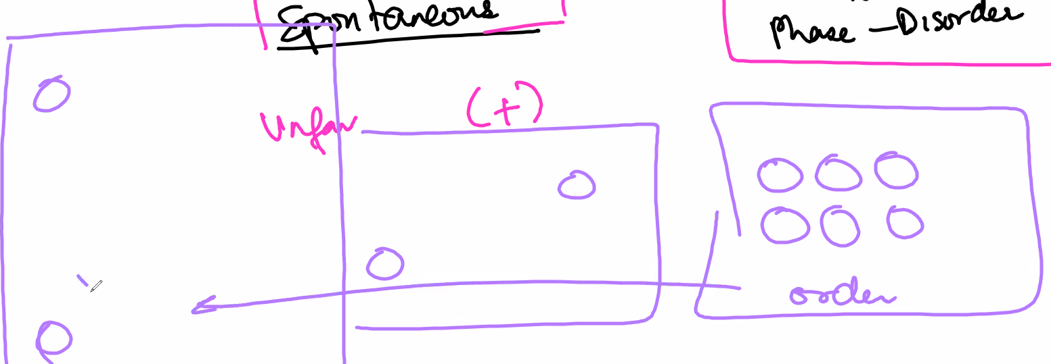

The molecules are more dispersed in a gas within a confined space

Higher entropy = more gaseous

* + - Must be positive
  + If only gas
    - Less moles of gas between the reactants and rpds means the entropy is decreasing (-)
      * 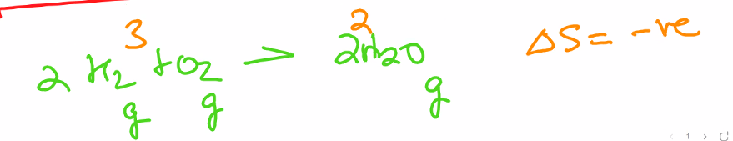
* Gibbs free energy
  + If reactions have energy left over, the reaction is called favorable or spontaneous
    - Spontaneous reactions are sustainable for more time
      * 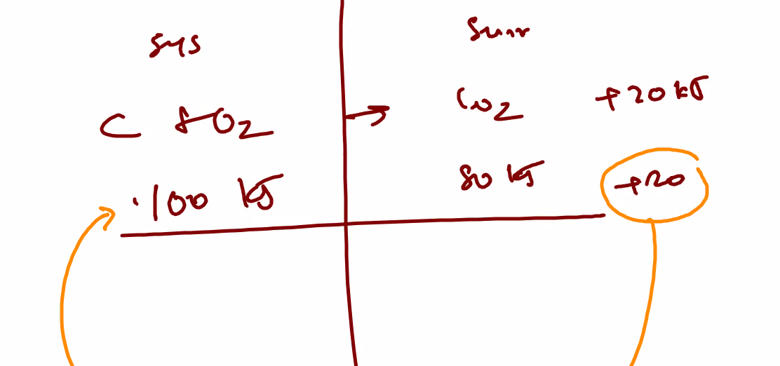
  + If this is negative, then that means you have energy left over and will be sent back to the exo
    - Will be sent back to the reactants
  + Favorable/Exergernic (Bio)
    - Means that the reaction is exothermic and hence sustainable
      * (energy will be sent back into the system)
  + Unfavorable/Endogernic (Bio)
    - Means that the reaction is endothermic and hunce unsustainable
      * (Energy is not automatically sent into the system, so energy has to be manually sent into the system)
  + 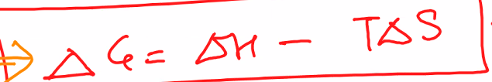
    - Delta G is gibbs free energy
    - Delta H is enthalpy
    - T is temp (KE)
    - Delta S is Entropy
* 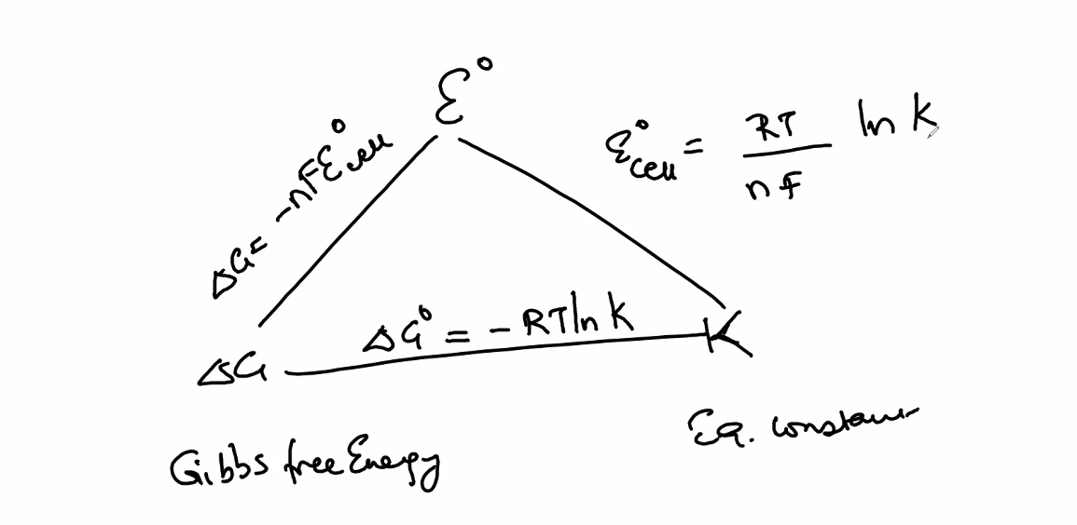
  + R = gas constant
    - Any time yuou are dealing with pressure, u can use either atm or pressure
    - Any time dealing with energy, 8.314 J/mol K would be used
  + T = temperature (always in kelvin)
  + △G = -nFE°Cell
    - (Equation is used to find gibbs free number)
    - F = 96,485 C
      * Faraday’s constant
      * C/mole of electrons
        + Multiply charge of electron by avogadros number
    - ° = it is of standard conditions
      * NOT DEGREES
    - -n = # of electrons
  + K =
  + Ln = natural logs
  + E not of cell
    - The potential of the galvanic cell to determine whether it is favorable or unfavorable
    - Standardized conditions
      * 25 degrees celsius
        + Considered room temp
      * 1 atm
    - Gasses have different standardized conditions because at room temp, gasses are indistinguishable
  + (Not listed) e- (electron) has charge of 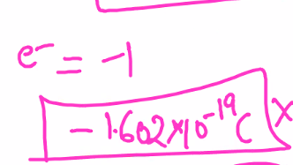
  + q = It
    - q = charge
      * Total charge ont he electrons that is flowing
        + cullumns
    - I = current
      * Amperage
        + Dependent on the batter of an electrolytic cell
    - t = time
* Electricity
  + Movement of electrons
  + 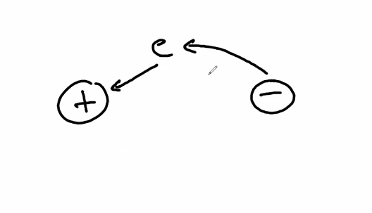
* Reduction potential
  + Ability to be reduced compared to other electrons
    - Use oxidization numbers to find the reduction & oxidization reactions
  + Anode is Oxidization
    - Negative RP/OP
    - Always loses mass
  + Cathode is Reduction
    - Positive RP/OP
    - Gaines mass
  + Electrolysis
* Reducitonn is the ability to gain electron
* 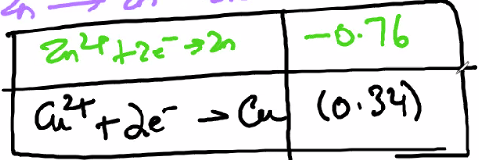
* Calculate E°Cell
  + 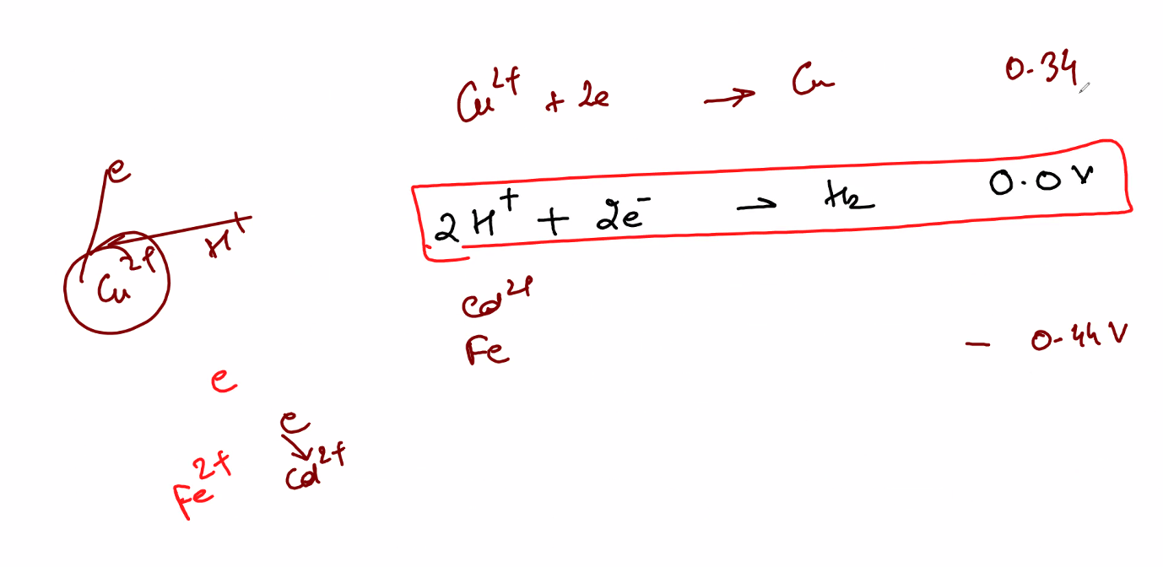
  + 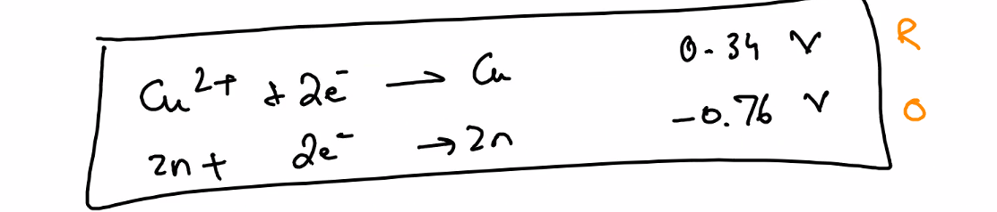
  + 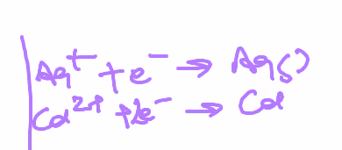
    - +V = Reduction
      * Electron is on the left
    - -V = oxidization
      * Electron is on the right
    - If electron is on the left for both, find the greater E°cell and this becomes the cathode (Reduction) -> the anode is oxidized
  + 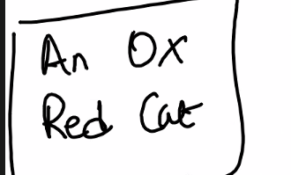
  + 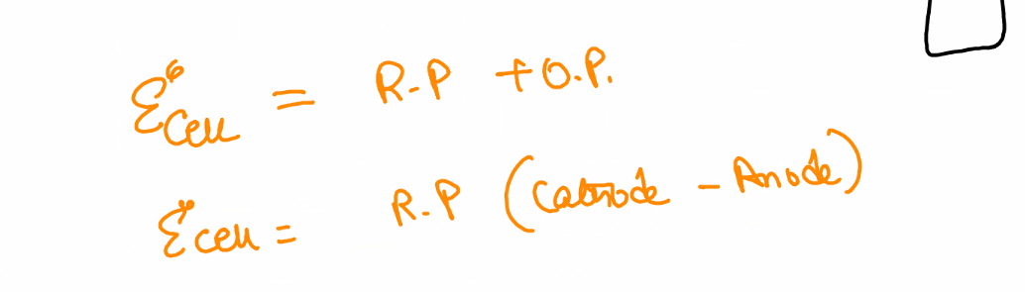
    - Top is for oxidization potential
      * If oxidization potential, make the negative reduction number (one of the anode) positive and add the who potential
    - Bottom is for reduction potential
      * If the
  + 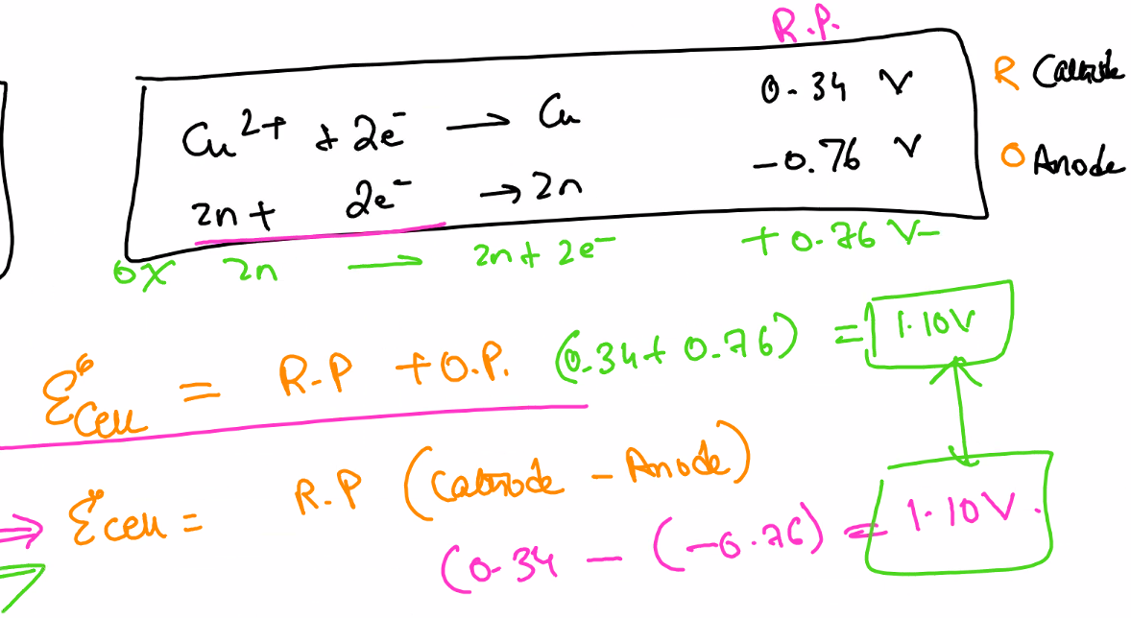
    - 2nd one is multiplied by -1 in order to become an oxidization numbr
    - Reduction should be positive
    - Never multiply voltage
  + 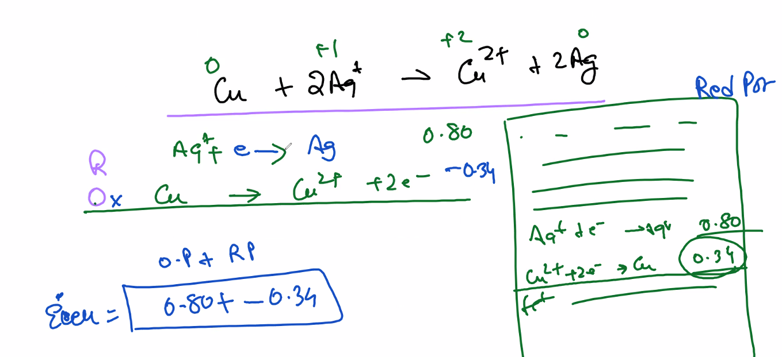
  + 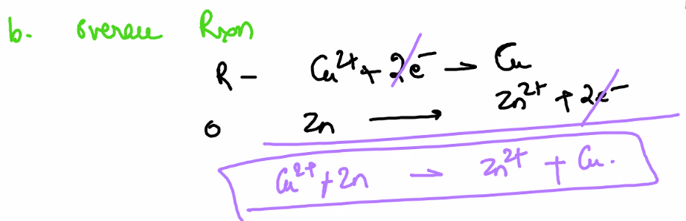
  + 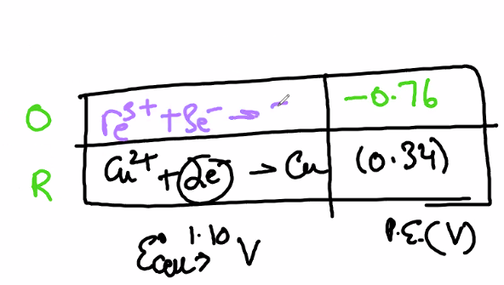
    - When given tables, find the original equation by balancing the equation according to the Electrons
      * 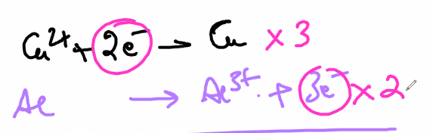
* ALL IONIC COMPOUNDS ARE SALTS
* Popular MC
  + 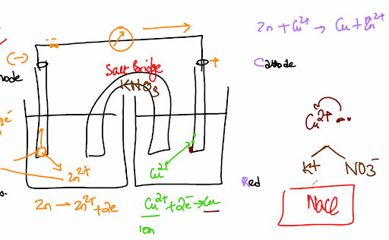
    - Salt Bridge is most likely KNO3
  + 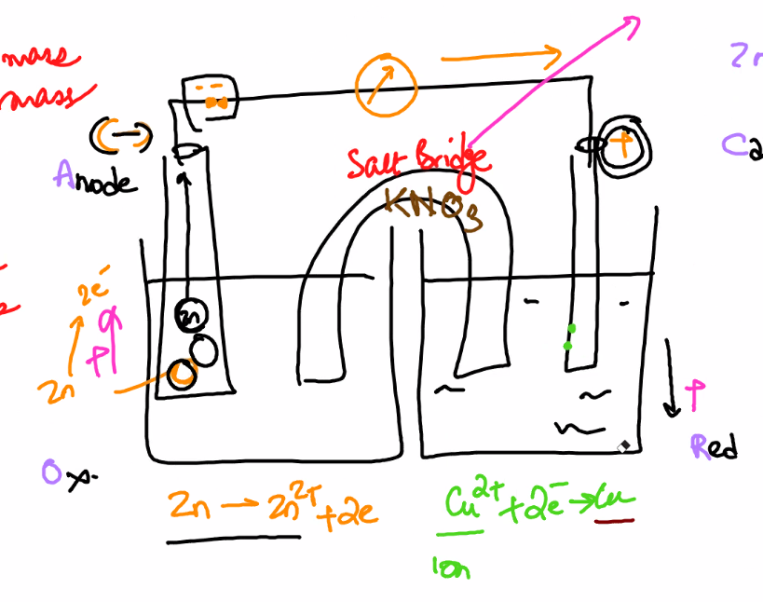
    - Zn is still a catho and will lose its electrons to give to copper, this makes the copper solute on the left side more positive than the left side
      * The electrons are attracted by the cathode manually put by the scientists & go to the copper
      * Creates Zn2+ in th eleft chamber
    - Since copper is a cathode & has positive charge, the negative charge of the electrons cancels out the cathode and makes it neutralized
    - Because the left chamber is hence more positively charged than the right, KNO3 is split apart and sent to the two chambers
      * K^- charge is sent to the Zn chamber
      * NO^3- charge is sent toth Cu chamber
  + 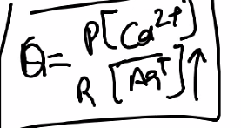
    - If the reactants increase, then the eq will shift to the right in the way of the products & hence the cell potential (E°) would increase
    - 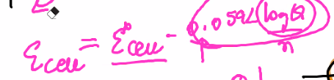
      * Because Q increases with greater products, and a greater Q means a smaller log of Q, that means a smaller number is subtracted from E°cell & hence ECell would decrease
  + 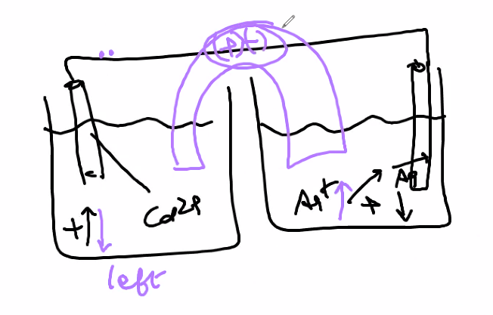
    - The anions will flow in the way of the cathode
      * These anions would maintain the positive charge within the Ag chamber
    - Since no table is given, you would use the reduction potentials in aqueous solution at 25 deg celcius to create your net ionic equation
* Cell
  + A redox reaction that is split into two chambers
  + Galvanic cells/Electrochemical cells
    - 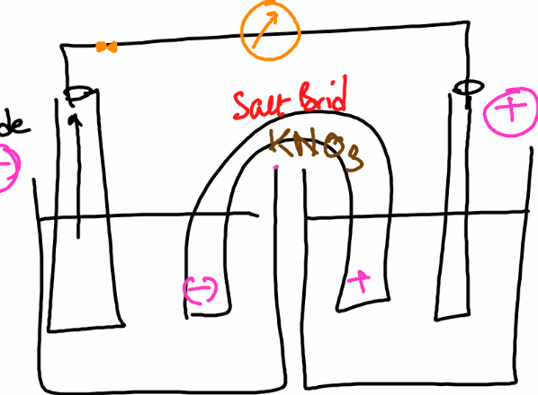
    - (Cathode & anode)
  + Electrolysis
    - Unfavorable reactions
    - Does not need a salt bridge
      * 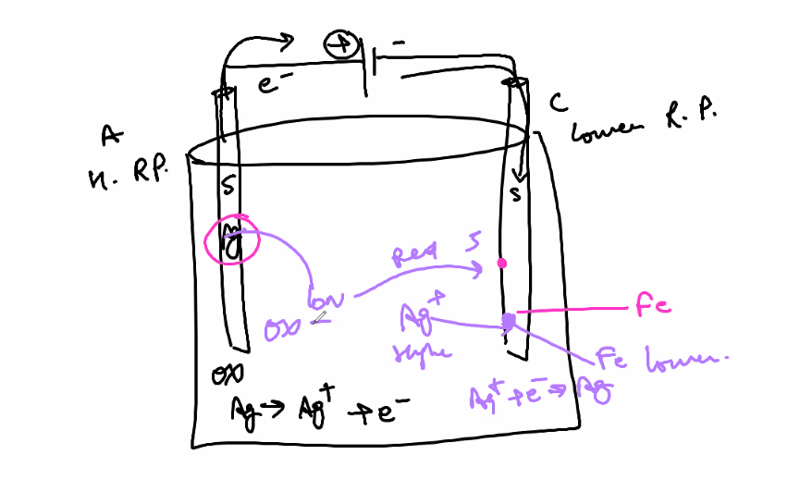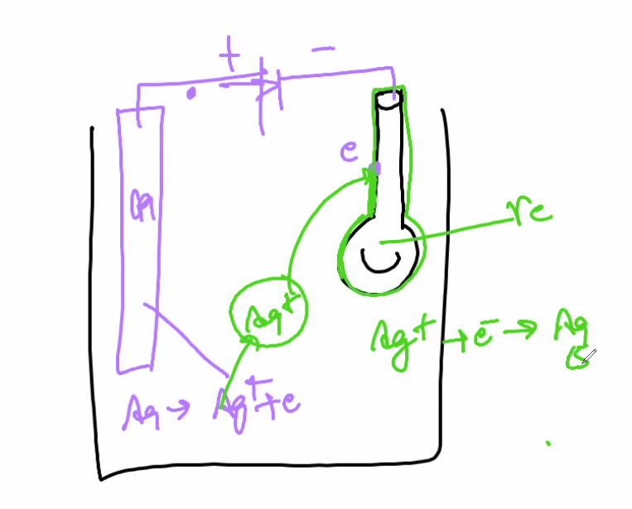
        + The battery at the top forcibly pulls the electrons out of the anodes

Because the reaction is unfavorable the battery is needed to continue the reaction

* + - * + The electron is sent to the cathode but because the anode has a higher RP, the anode bonds with the anode again to
      * Used for purifying elements
        + Anode is impure
        + Cathode is pure

MC TIP (Only for electrolysis)

* + - 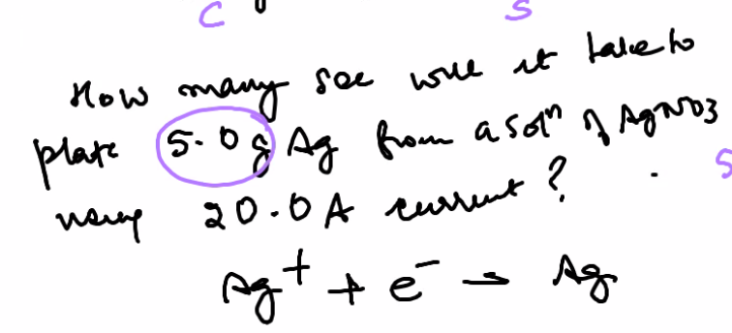
      * Example stoich question
        + 1. Find reduction pot of AG to find the # of electrons needed

Since one mole is needed per electron, Multiply moles by faradays constant (charge of electrons in mole)

* + - * + 2. Convert 5.0g to moles
        + 3. Multiply moles by faradays constant (charge of electrons in mole)
        + 4. Use t = q/i to solve for time
* Acids & bases
  + Weak acids & bases will have equilibrium
    - Will not disassociate stuff 100%
  + Strong acids & bases will be done with stoich
    - Will disassociate stuff less than 100%
  + 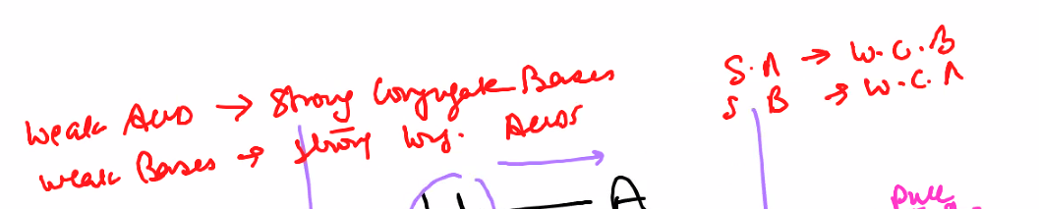
    - Weak conjugates do not undergo hydrolysis
      * 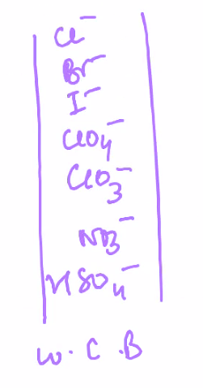
      * 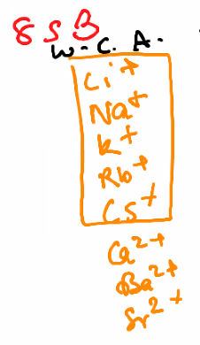
      * 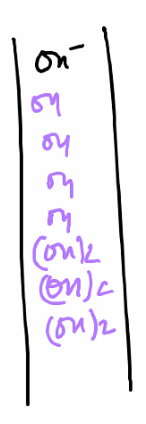
    - Hydrolysis means that it can react with water
  + Classifying acids & bases
    - Arrhenius
      * H+ H-
    - Barnstead-Lowry
      * Protons lost & protons accepted
    - 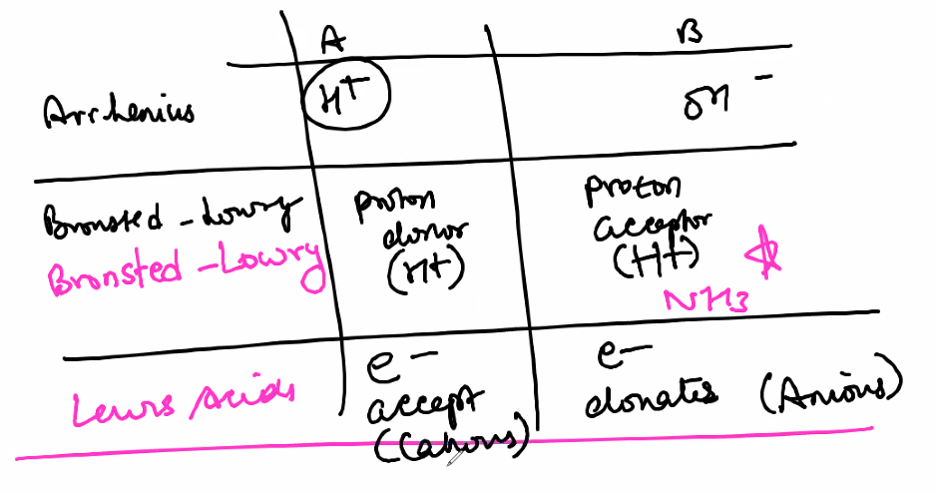
  + Conjugates
    - If you remove an H+ from an acid, what is left over is the conjugate base
      * Acid - H+
    - If you add an H+ to a base, it becomes a conjugate acid
      * Base + H+
    - 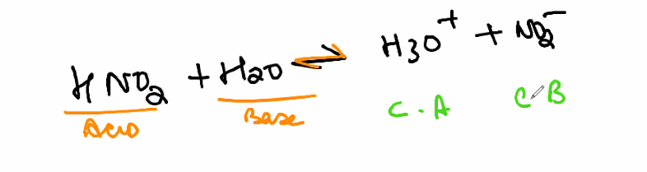
  + Amphoteric
    - Substances that act both as acids & bases
      * 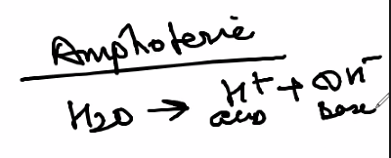
      * 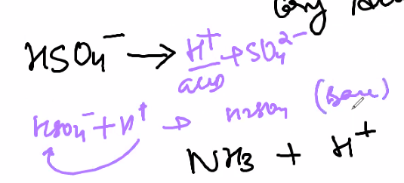
      * 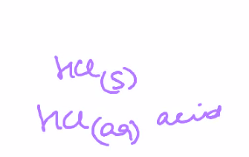
        + The water pulls away the H+ ion
  + Strength of an acid
    - The concentration of Hydrogen Ions in solution
  + Titration
    - 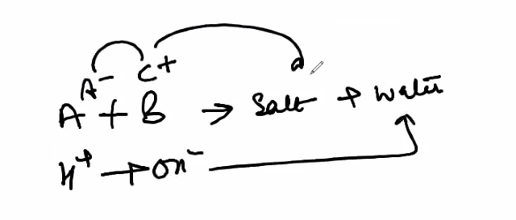
  + Will always be given molarity and volume of solution (least likely give moles)
    - Use m*V to get moles
* Reaction stoich
  + 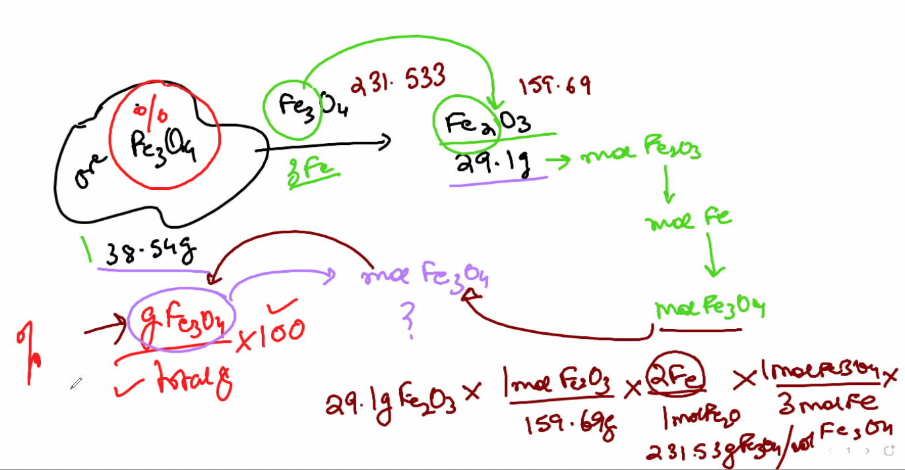
  + Chain of reactions then hess’s law
* Atomic structure
* Per table trends